Chapter I
Introduction

  - Background
Information Technology has revolutionized the life of human beings’ and has made the lives easier by the various kinds of applications. In the light of the rapid changes with the use of IT, there are many tools, technologies and systems have been produced and invented. In the modern world, time is short so if there are many processes taken place at same time within a place there is a need for integration of all the processes, creation of paperless environment also ensures efficient task management.

Nowadays all the businesses are shifting to computer based system. The purpose to having a computer based system is, it helps to increase the market share and it’s very easy for customers to use. It is increasing the demand among the customer. This project is concerned with developing a Library Management System (LMS) is a web based application developed by using C#.net, SQL and Visual Studio for school/ college library. Library Management System provide a simple GUI (graphical user interface) for the Library Staff to manage the functions of the library effectively. Usually when a book is return or issued, it is noted down in a register after which data entry is done to update the status of the books in a moderate scale. This process takes some time and proper updation cannot be guaranteed. Such anomalies in the updation process can cause loss of books. So a more user friendly interface which could update the database instanatly, has a great demand in libraries.

  - Problems Statements

Many library systems are operated manually by group of people. In such situations many people involved in the process of managing the library such a way that to keep records regarding the books & students (borrowers), check the books manually, keep records on issued books etc. all these things have to be carried out manually & if the library is large in content handling is also a problem. On the other hand keeping large amount of maintenance workers may cost a lot & it will not be efficient for a library. Manual record keeping is also not a reliable method as people tend to forget things. On the borrower’s point of view, in manual system borrower can’t find a book exactly at once as they are not ordered well. Sometimes user might be searching for a book that is not available in the library in such situations people get annoyed or depressed.

In developing countries where the computerized is a mature technology, development are in the area of resources sharing and globalization of information access. In such scenario, the role of the school, college & university is no longer to provide the most appropriate book per article but have become to seek out the information required by the borrower from any library. This Library Management system is designed to help librarian staff for effectively do their daily transactions and to monitor on the log in/ logout of students and the borrowing and returning of the books. This system track about all transaction of library i.e. storing details of a large number of books, magazines, Journals, thesis and allow for add, search, borrow, return facilities separately to administrator/Librarian, staff and students. This system keeps track of the books, if any book is lost from library this system trace out who lost the books or who did not returned it on the time.

  - Objectives

The Specific objectives of the LMS:
- Develop a system that can replace the manual library managing system.
- Develop a database which stores user details & book details.
- Give reliable search facility for the users.
- Administrator, librarian & users should have separate logins.
- Create an easy to understand user friendly environment.
- Attractive user interfaces to navigate through the system for the users.
- Develop the system documentation with detailed UML specifications

  - Scope of the Project

The aim of this project is to develop a system that can handle & manage the activities involved in a library in an efficient & reliable way. The goal of the system is to bring down the work load with the increased efficiency and to speed up the activities. With this it is very easy to process course fee that is collected time to time from students who are registered and studying at franchisees.

  - System Specification

Hardware Requirements:

- CPU-Pentium 4 (Processor) and above, or any other equivalent.
- RAM-512 MB and above
- Cache Memory-512 KB
- Hard Disk- 20 GB and above
- Mouse/Keyboard/Printer
- 15.1” Screen Personal Laptop

Software Requirements :

- Operating System – Windows 95/98/XP/7 with MS-office
- Programming language- .NET2.0, Visual Studio 2005, 2008 or 2010
- Web- Technology – ASP.NET
- Back-End- SQL Server 2005 or above.
- Web Server – Internet Information System (IIS)

Chapter II
System Study and Analysis
2.1 Existing System

Various problems of physical system are described below :-

- If one is not very careful then there is a possibility of issuing more than one book to a user.
- There is a possibility of issuing a book to a user, whose membership is not there.
- When a user requests for the a book, one has to physically check for the presence of a book in the library.
- Answering management query is a time consuming process.
- Daily keeping a manual record of changes taking place in the library such as book being issued, book being returned etc can become cumbersome

2.2 Proposed system

The LIBRARY MANAGEMENT SYSTEM is a software application which avoids more manual hours in taking the book, that need to spend in record keeping and generating reports. Maintaining of user details is complex in manual system in terms of agreements, royalty and activities. This all have to be maintained in ledgers or books. Co-coordinators needs to verify each record for small information also.

- Easy search of book in the online library.

- Avoid the manual work.

- User need not go to the library for Issue any kind of book, he can renewal the book online.

2.3 Technologies used

FRONT END TECHNOLOGY

Microsoft .NET Framework
The .NET Framework is a new computing platform that simplifies application development in the highly distributed environment of the Internet. The .NET Framework is designed to fulfill the following objectives:
- To provide a consistent object-oriented programming environment whether object code is stored and executed locally, executed locally but Internet-distributed, or executed remotely.
- To provide a code-execution environment that minimizes software deployment and versioning conflicts.
- To provide a code-execution environment that guarantees safe execution of code, including code created by an unknown or semi-trusted third party.
- To provide a code-execution environment that eliminates the performance problems of scripted or interpreted environments.
- To make the developer experience consistent across widely varying types of applications, such as Windows-based applications and Web-based applications.
- To build all communication on industry standards to ensure that code based on the .NET Framework can integrate with any other code.
The .NET Framework has two main components: the common language runtime and the .NET Framework class library. The common language runtime is the foundation of the .NET Framework. You can think of the runtime as an agent that manages code at execution time, providing core services such as memory management, thread management, and remoting, while also enforcing strict type safety and other forms of code accuracy that ensure security and robustness. In fact, the concept of code management is a fundamental principle of the runtime. Code that targets the runtime is known as managed code, while code that does not target the runtime is known as unmanaged code. The class library, the other main component of the .NET Framework, is a comprehensive, object-oriented collection of reusable types that you can use to develop applications ranging from traditional command-line or graphical user interface (GUI) applications to applications based on the latest innovations provided by ASP.NET, such as Web Forms and XML Web services.
The .NET Framework can be hosted by unmanaged components that load the common language runtime into their processes and initiate the execution of managed code, thereby creating a software environment that can exploit both managed and unmanaged features. The .NET Framework not only provides several runtime hosts, but also supports the development of third-party runtime hosts.
For example, ASP.NET hosts the runtime to provide a scalable, server-side environment for managed code. ASP.NET works directly with the runtime to enable Web Forms applications and XML Web services, both of which are discussed later in this topic.
Internet Explorer is an example of an unmanaged application that hosts the runtime (in the form of a MIME type extension). Using Internet Explorer to host the runtime enables you to embed managed components or Windows Forms controls in HTML documents. Hosting the runtime in this way makes managed mobile code (similar to Microsoft® ActiveX® controls) possible, but with significant improvements that only managed code can offer, such as semi-trusted execution and secure isolated file storage.
The following illustration shows the relationship of the common language runtime and the class library to your applications and to the overall system. The illustration also shows how managed code operates within a larger architecture.

Features of the Common Language Runtime:-
The common language runtime manages memory, thread execution, code execution, code safety verification, compilation, and other system services. These features are intrinsic to the managed code that runs on the common language runtime.
With regards to security, managed components are awarded varying degrees of trust, depending on a number of factors that include their origin (such as the Internet, enterprise network, or local computer). This means that a managed component might or might not be able to perform file-access operations, registry-access operations, or other sensitive functions, even if it is being used in the same active application.
The runtime enforces code access security. For example, users can trust that an executable embedded in a Web page can play an animation on screen or sing a song, but cannot access their personal data, file system, or network. The security features of the runtime thus enable legitimate Internet-deployed software to be exceptionally featuring rich.
The runtime also enforces code robustness by implementing a strict type- and code-verification infrastructure called the common type system (CTS). The CTS ensures that all managed code is self-describing. The various Microsoft and third-party language compilers generate managed code that conforms to the CTS. This means that managed code can consume other managed types and instances, while strictly enforcing type fidelity and type safety.
In addition, the managed environment of the runtime eliminates many common software issues. For example, the runtime automatically handles object layout and manages references to objects, releasing them when they are no longer being used. This automatic memory management resolves the two most common application errors, memory leaks and invalid memory references.
The runtime also accelerates developer productivity. For example, programmers can write applications in their development language of choice, yet take full advantage of the runtime, the class library, and components written in other languages by other developers. Any compiler vendor who chooses to target the runtime can do so. Language compilers that target the .NET Framework make the features of the .NET Framework available to existing code written in that language, greatly easing the migration process for existing applications.
While the runtime is designed for the software of the future, it also supports software of today and yesterday. Interoperability between managed and unmanaged code enables developers to continue to use necessary COM components and DLLs.
The runtime is designed to enhance performance. Although the common language runtime provides many standard runtime services, managed code is never interpreted. A feature called just-in-time (JIT) compiling enables all managed code to run in the native machine language of the system on which it is executing. Meanwhile, the memory manager removes the possibilities of fragmented memory and increases memory locality-of-reference to further increase performance.
Finally, the runtime can be hosted by high-performance, server-side applications, such as Microsoft® SQL Server™ and Internet Information Services (IIS). This infrastructure enables you to use managed code to write your business logic, while still enjoying the superior performance of the industry's best enterprise servers that support runtime hosting.

.NET Framework Class Library:-
The .NET Framework class library is a collection of reusable types that tightly integrate with the common language runtime. The class library is object oriented, providing types from which your own managed code can derive functionality. This not only makes the .NET Framework types easy to use, but also reduces the time associated with learning new features of the .NET Framework. In addition, third-party components can integrate seamlessly with classes in the .NET Framework.
For example, the .NET Framework collection classes implement a set of interfaces that you can use to develop your own collection classes. Your collection classes will blend seamlessly with the classes in the .NET Framework.
As you would expect from an object-oriented class library, the .NET Framework types enable you to accomplish a range of common programming tasks, including tasks such as string management, data collection, database connectivity, and file access. In addition to these common tasks, the class library includes types that support a variety of specialized development scenarios. For example, you can use the .NET Framework to develop the following types of applications and services:
- Console applications.
- Scripted or hosted applications.
- Windows GUI applications (Windows Forms).
- ASP.NET applications.
- XML Web services.
- Windows services.
For example, the Windows Forms classes are a comprehensive set of reusable types that vastly simplify Windows GUI development. If you write an ASP.NET Web Form application, you can use the Web Forms classes.

Client Application Development:-
Client applications are the closest to a traditional style of application in Windows-based programming. These are the types of applications that display windows or forms on the desktop, enabling a user to perform a task. Client applications include applications such as word processors and spreadsheets, as well as custom business applications such as data-entry tools, reporting tools, and so on. Client applications usually employ windows, menus, buttons, and other GUI elements, and they likely access local resources such as the file system and peripherals such as printers.
Another kind of client application is the traditional ActiveX control (now replaced by the managed Windows Forms control) deployed over the Internet as a Web page. This application is much like other client applications: it is executed natively, has access to local resources, and includes graphical elements.
In the past, developers created such applications using C/C++ in conjunction with the Microsoft Foundation Classes (MFC) or with a rapid application development (RAD) environment such as Microsoft® Visual Basic®. The .NET Framework incorporates aspects of these existing products into a single, consistent development environment that drastically simplifies the development of client applications. The Windows Forms classes contained in the .NET Framework are designed to be used for GUI development. You can easily create command windows, buttons, menus, toolbars, and other screen elements with the flexibility necessary to accommodate shifting business needs.
For example, the .NET Framework provides simple properties to adjust visual attributes associated with forms. In some cases the underlying operating system does not support changing these attributes directly, and in these cases the .NET Framework automatically recreates the forms. This is one of many ways in which the .NET Framework integrates the developer interface, making coding simpler and more consistent.
Unlike ActiveX controls, Windows Forms controls have semi-trusted access to a user's computer. This means that binary or natively executing code can access some of the resources on the user's system (such as GUI elements and limited file access) without being able to access or compromise other resources. Because of code access security, many applications that once needed to be installed on a user's system can now be safely deployed through the Web. Your applications can implement the features of a local application while being deployed like a Web page.

Server Application Development:-
Server-side applications in the managed world are implemented through runtime hosts. Unmanaged applications host the common language runtime, which allows your custom managed code to control the behavior of the server. This model provides you with all the features of the common language runtime and class library while gaining the performance and scalability of the host server.
The following illustration shows a basic network schema with managed code running in different server environments. Servers such as IIS and SQL Server can perform standard operations while your application logic executes through the managed code.
Server-side managed code:-
ASP.NET is the hosting environment that enables developers to use the .NET Framework to target Web-based applications. However, ASP.NET is more than just a runtime host; it is a complete architecture for developing Web sites and Internet-distributed objects using managed code. Both Web Forms and XML Web services use IIS and ASP.NET as the publishing mechanism for applications, and both have a collection of supporting classes in the .NET Framework.
XML Web services, an important evolution in Web-based technology, are distributed, server-side application components similar to common Web sites. However, unlike Web-based applications, XML Web services components have no UI and are not targeted for browsers such as Internet Explorer and Netscape Navigator. Instead, XML Web services consist of reusable software components designed to be consumed by other applications, such as traditional client applications, Web-based applications, or even other XML Web services. As a result, XML Web services technology is rapidly moving application development and deployment into the highly distributed environment of the Internet.
If you have used earlier versions of ASP technology, you will immediately notice the improvements that ASP.NET and Web Forms offers. For example, you can develop Web Forms pages in any language that supports the .NET Framework. In addition, your code no longer needs to share the same file with your HTTP text (although it can continue to do so if you prefer). Web Forms pages execute in native machine language because, like any other managed application, they take full advantage of the runtime. In contrast, unmanaged ASP pages are always scripted and interpreted. ASP.NET pages are faster, more functional, and easier to develop than unmanaged ASP pages because they interact with the runtime like any managed application.
The .NET Framework also provides a collection of classes and tools to aid in development and consumption of XML Web services applications. XML Web services are built on standards such as SOAP (a remote procedure-call protocol), XML (an extensible data format), and WSDL ( the Web Services Description Language). The .NET Framework is built on these standards to promote interoperability with non-Microsoft solutions.
For example, the Web Services Description Language tool included with the .NET Framework SDK can query an XML Web service published on the Web, parse its WSDL description, and produce C# or Visual Basic source code that your application can use to become a client of the XML Web service. The source code can create classes derived from classes in the class library that handle all the underlying communication using SOAP and XML parsing. Although you can use the class library to consume XML Web services directly, the Web Services Description Language tool and the other tools contained in the SDK facilitate your development efforts with the .NET Framework.
If you develop and publish your own XML Web service, the .NET Framework provides a set of classes that conform to all the underlying communication standards, such as SOAP, WSDL, and XML. Using those classes enables you to focus on the logic of your service, without concerning yourself with the communications infrastructure required by distributed software development.
Finally, like Web Forms pages in the managed environment, your XML Web service will run with the speed of native machine language using the scalable communication of IIS.
Active Server Pages.NET:-
ASP.NET is a programming framework built on the common language runtime that can be used on a server to build powerful Web applications. ASP.NET offers several important advantages over previous Web development models:

- Enhanced Performance:
ASP.NET is compiled common language runtime code running on the server. Unlike its interpreted predecessors, ASP.NET can take advantage of early binding, just-in-time compilation, native optimization, and caching services right out of the box. This amounts to dramatically better performance before you ever write a line of code.
- World-Class Tool Support:
The ASP.NET framework is complemented by a rich toolbox and designer in the Visual Studio integrated development environment. WYSIWYG editing, drag-and-drop server controls, and automatic deployment are just a few of the features this powerful tool provides.
- Power and Flexibility:
Because ASP.NET is based on the common language runtime, the power and flexibility of that entire platform is available to Web application developers. The .NET Framework class library, Messaging, and Data Access solutions are all seamlessly accessible from the Web. ASP.NET is also language-independent, so you can choose the language that best applies to your application or partition your application across many languages. Further, common language runtime interoperability guarantees that your existing investment in COM-based development is preserved when migrating to ASP.NET.
- Simplicity:
ASP.NET makes it easy to perform common tasks, from simple form submission and client authentication to deployment and site configuration. For example, the ASP.NET page framework allows you to build user interfaces that cleanly separate application logic from presentation code and to handle events in a simple, Visual Basic - like forms processing model. Additionally, the common language runtime simplifies development, with managed code services such as automatic reference counting and garbage collection.
- Manageability:
ASP.NET employs a text-based, hierarchical configuration system, which simplifies applying settings to your server environment and Web applications. Because configuration information is stored as plain text, new settings may be applied without the aid of local administration tools. This "zero local administration" philosophy extends to deploying ASP.NET Framework applications as well. An ASP.NET Framework application is deployed to a server simply by copying the necessary files to the server. No server restart is required, even to deploy or replace running compiled code.
- Scalability and Availability:
ASP.NET has been designed with scalability in mind, with features specifically tailored to improve performance in clustered and multiprocessor environments. Further, processes are closely monitored and managed by the ASP.NET runtime, so that if one misbehaves (leaks, deadlocks), a new process can be created in its place, which helps keep your application constantly available to handle requests.
- Customizability and Extensibility:
ASP.NET delivers a well-factored architecture that allows developers to "plug-in" their code at the appropriate level. In fact, it is possible to extend or replace any subcomponent of the ASP.NET runtime with your own custom-written component. Implementing custom authentication or state services has never been easier.
- Security:
With built in Windows authentication and per-application configuration, you can be assured that your applications are secure.

Language Support
The Microsoft .NET Platform currently offers built-in support for three languages: C#, Visual Basic, and JScript.

BACK END TECHNOLOGY:

About Microsoft SQL Server 2000
Microsoft SQL Server is a Structured Query Language (SQL) based, client/server relational database. Each of these terms describes a fundamental part of the architecture of SQL Server.
Database
A database is similar to a data file in that it is a storage place for data. Like a data file, a database does not present information directly to a user; the user runs an application that accesses data from the database and presents it to the user in an understandable format.

A database typically has two components: the files holding the physical database and the database management system (DBMS) software that applications use to access data. The DBMS is responsible for enforcing the database structure, including:
- Maintaining the relationships between data in the database.
- Ensuring that data is stored correctly and that the rules defining data relationships are not violated.
- Recovering all data to a point of known consistency in case of system
failures.

Relational Database
There are different ways to organize data in a database but relational databases are one of the most effective. Relational database systems are an application of mathematical set theory to the problem of effectively organizing data. In a relational database, data is collected into tables (called relations in relational theory).
When organizing data into tables, you can usually find many different ways to define tables. Relational database theory defines a process, normalization, which ensures that the set of tables you define will organize your data effectively.

Client/Server:-
In a client/server system, the server is a relatively large computer in a central location that manages a resource used by many people. When individuals need to use the resource, they connect over the network from their computers, or clients, to the server.
Examples of servers are: In a client/server database architecture, the database files and DBMS software reside on a server. A communications component is provided so applications can run on separate clients and communicate to the database server over a network. The SQL Server communication component also allows communication between an application running on the server and SQL Server.
Server applications are usually capable of working with several clients at the same time. SQL Server can work with thousands of client applications simultaneously. The server has features to prevent the logical problems that occur if a user tries to read or modify data currently being used by others.

While SQL Server is designed to work as a server in a client/server network, it is also capable of working as a stand-alone database directly on the client. The scalability and ease-of-use features of SQL Server allow it to work efficiently on a client without consuming too many resources.

Structured Query Language (SQL):-

To work with data in a database, you must use a set of commands and statements (language) defined by the DBMS software. There are several different languages that can be used with relational databases; the most common is SQL. Both the American National Standards Institute (ANSI) and the International Standards Organization (ISO) have defined standards for SQL. Most modern DBMS products support the Entry Level of SQL-92, the latest SQL standard (published in 1992).

SQL Server Features
Microsoft SQL Server supports a set of features that result in the following benefits:

Ease of installation, deployment, and use
SQL Server includes a set of administrative and development tools that improve your ability to install, deploy, manage, and use SQL Server across several sites.

Scalability
The same database engine can be used across platforms ranging from laptop computers running Microsoft Windows® 95/98 to large, multiprocessor servers running Microsoft Windows NT®, Enterprise Edition.

Data warehousing
SQL Server includes tools for extracting and analyzing summary data for online analytical processing (OLAP). SQL Server also includes tools for visually designing databases and analyzing data using English-based questions.

System integration with other server software
SQL Server integrates with e-mail, the Internet, and Windows.

Databases
A database in Microsoft SQL Server consists of a collection of tables that contain data, and other objects, such as views, indexes, stored procedures, and triggers, defined to support activities performed with the data. The data stored in a database is usually related to a particular subject or process, such as inventory information for a manufacturing warehouse.
SQL Server can support many databases, and each database can store either interrelated data or data unrelated to that in the other databases. For example, a server can have one database that stores personnel data and another that stores product-related data. Alternatively, one database can store current customer order data, and another; related database can store historical customer orders that are used for yearly reporting. Before you create a database, it is important to understand the parts of a database and how to design these parts to ensure that the database performs well after it is implemented.

Normalization theory:
Relations are to be normalized to avoid anomalies. In insert, update and delete operations. Normalization theory is built around the concept of normal forms. A relation is said to be in a particular form if it satisfies a certain specified set if constraints. To decide a suitable logical structure for given database design the concept of normalization, which are briefly described below.

- 1 st Normal Form (1 N.F): A relation is said to be in 1 NF is and only if all unaligned domains contain values only. That is the fields of an n-set should have no group items and no repeating groups.
- 2 nd Normal Form (2 N.F) : A relation is said to be in 2 NF is and only if it is in 1 NF and every non key attribute is fully dependent on primary key. This normal takes care of functional dependencies on non-key attributes.
- 3 rd Normal Form (3 N.F) : A relation is said to be in 3 NF is and only if it is in 2 NF and every non key attribute is non transitively dependent on the primary key. This normal form avoids the transitive dependencies on the primary key.
- Boyce code Normal Form (BCNF) : This is a stronger definition than that of NF. A relation is said to be in BCNF if and only if every determinant is a Candidate key.
5. 4 th Normal Form (4 NF) : A relation is said to be in 4 NF if and only if whenever there exists a multi valued dependency in a relation say A->->B then all of the relation are also functionally dependent on A(i.e. A->X for all attributes x of the relation.).
6. 5 th Normal Form (5 NF) OR Projection Join Normal Form (PJNF): A relation R is in 5 NF .if and only if every join dependency in R is implied by the candidate key on R . A relation can’t be non-loss split into two tables but can be split into three tables. This is called Join Dependency.

MIDDLEWARE TECHNOLOGY

Activex Data Objects.Net Overview
ADO.NET is an evolution of the ADO data access model that directly addresses user requirements for developing scalable applications. It was designed specifically for the web with scalability, statelessness, and XML in mind.
ADO.NET uses some ADO objects, such as the Connection and Command objects, and also introduces new objects. Key new ADO.NET objects include the Dataset, Data Reader, and Data Adapter.
The important distinction between this evolved stage of ADO.NET and previous data architectures is that there exists an object -- the Dataset -- that is separate and distinct from any data stores. Because of that, the Dataset functions as a standalone entity. You can think of the Dataset as an always disconnected record set that knows nothing about the source or destination of the data it contains. Inside a Dataset, much like in a database, there are tables, columns, relationships, constraints, views, and so forth.
A Data Adapter is the object that connects to the database to fill the Dataset. Then, it connects back to the database to update the data there, based on operations performed while the Dataset held the data. In the past, data processing has been primarily connection-based. Now, in an effort to make multi-tiered apps more efficient, data processing is turning to a message-based approach that revolves around chunks of information. At the center of this approach is the Data Adapter, which provides a bridge to retrieve and save data between a Dataset and its source data store. It accomplishes this by means of requests to the appropriate SQL commands made against the data store.
The XML-based Dataset object provides a consistent programming model that works with all models of data storage: flat, relational, and hierarchical. It does this by having no 'knowledge' of the source of its data, and by representing the data that it holds as collections and data types. No matter what the source of the data within the Dataset is, it is manipulated through the same set of standard APIs exposed through the Dataset and its subordinate objects.
While the Dataset has no knowledge of the source of its data, the managed provider has detailed and specific information. The role of the managed provider is to connect, fill, and persist the Dataset to and from data stores. The OLE DB and SQL Server .NET Data Providers (System.Data.OleDb and System.Data.SqlClient) that are part of the .Net Framework provide four basic objects: the Command, Connection, Data Reader and Data Adapter. In the remaining sections of this document, we'll walk through each part of the Dataset and the OLE DB/SQL Server .NET Data Providers explaining what they are, and how to program against them. The following sections will introduce you to some objects that have evolved, and some that are new. These objects are:
- Connections. For connection to and managing transactions against a database.
- Commands. For issuing SQL commands against a database.
- Data Readers. For reading a forward-only stream of data records from a SQL Server data source.
- Datasets. For storing, removing and programming against flat data, XML data and relational data.
- Data Adapters. For pushing data into a Dataset, and reconciling data against a database.
When dealing with connections to a database, there are two different options: SQL Server .NET Data Provider (System.Data.SqlClient) and OLE DB .NET Data Provider (System.Data.OleDb). In these samples we will use the SQL Server .NET Data Provider. These are written to talk directly to Microsoft SQL Server. The OLE DB .NET Data Provider is used to talk to any OLE DB provider (as it uses OLE DB underneath).
Connections
Connections are used to 'talk to' databases, and are represented by provider-specific classes such as SQLConnection. Commands travel over connections and result sets are returned in the form of streams which can be read by a Data Reader object, or pushed into a Dataset object.
Commands
Commands contain the information that is submitted to a database, and are represented by provider-specific classes such as SQLCommand. A command can be a stored procedure call, an UPDATE statement, or a statement that returns results. You can also use input and output parameters, and return values as part of your command syntax. The example below shows how to issue an INSERT statement against the North wind database.
Data Readers
The Data Reader object is somewhat synonymous with a read-only/forward-only cursor over data. The Data Reader API supports flat as well as hierarchical data. A Data Reader object is returned after executing a command against a database. The format of the returned Data Reader object is different from a record set. For example, you might use the Data Reader to show the results of a search list in a web page.

Datasets
The Dataset object is similar to the ADO Record set object, but more powerful, and with one other important distinction: the Dataset is always disconnected. The Dataset object represents a cache of data, with database-like structures such as tables, columns, relationships, and constraints. However, though a Dataset can and does behave much like a database, it is important to remember that Dataset objects do not interact directly with databases, or other source data. This allows the developer to work with a programming model that is always consistent, regardless of where the source data resides. Data coming from a database, an XML file, from code, or user input can all be placed into Dataset objects. Then, as changes are made to the Dataset they can be tracked and verified before updating the source data. The Get Changes method of the Dataset object actually creates a second Dataset that contains only the changes to the data. This Dataset is then used by a Data Adapter (or other objects) to update the original data source. The Dataset has many XML characteristics, including the ability to produce and consume XML data and XML schemas. XML schemas can be used to describe schemas interchanged via Web Services. In fact, a Dataset with a schema can actually be compiled for type safety and statement completion.

Data Adapters (OLEDB/SQL)
The Data Adapter object works as a bridge between the Dataset and the source data. Using the provider-specific SqlDataAdapter (along with its associated SqlCommand and SqlConnection) can increase overall performance when working with a Microsoft SQL Server databases. For other OLE DB-supported databases, you would use the OleDbDataAdapter object and its associated OleDbCommand and OleDbConnection objects. The Data Adapter object uses commands to update the data source after changes have been made to the Dataset. Using the Fill method of the Data Adapter calls the SELECT command; using the Update method calls the INSERT, UPDATE or DELETE command for each changed row. You can explicitly set these commands in order to control the statements used at runtime to resolve changes, including the use of stored procedures. For ad-hoc scenarios, a Command Builder object can generate these at run-time based upon a select statement. However, this run-time generation requires an extra round-trip to the server in order to gather required metadata, so explicitly providing the INSERT, UPDATE, and DELETE commands at design time will result in better run-time performance.
- ADO.NET is the next evolution of ADO for the .Net Framework.
- ADO.NET was created with n-Tier, statelessness and XML in the forefront. Two new objects, the Dataset and Data Adapter, are provided for these scenarios. ADO.NET can be used to get data from a stream, or to store data in a cache for updates.
- There is a lot more information about ADO.NET in the documentation.
- Remember, you can execute a command directly against the database in order to do inserts, updates, and deletes. You don't need to first put data into a Dataset in order to insert, update, or delete it.
- Also, you can use a Dataset to bind to the data, move through the data, and navigate data relationships
Functions

Functions are bet declared between the <Head> tag of HTML page. Functions are called by user-initiated events. Seems reasonable to keep the functions between the <Head> tags. They are loaded first before a user can do anything that might call a function. Scripts can be placed between inside comment fields to ensure that older browser do not display the script itself.
<html>
<head>
<script language=”JavaScript”>
function pushbutton (){
alert (“Hello!”);
}
</script>
</head>
<body>
<form>
<input type=”button” name=”Button1” value=”push me” onclick=”pushbutton ()”>
</form>
</body>
</html>

If we want to test this one immediately and you are using a Java Script enabled browser then please go ahead and push the button.
This script will create a button and when you press it a window will pop up saying “hello!”. In fact we have a lot of possibilities just by adding functions to our scripts.
The common browsers transmit the form information by either method: here’s the complete tag including the GET transmission method attribute for the previous form

Example

<Form method =GET action=http://www.mycompany.com/cgi-bin/upfdate.pl>
………
</form>

Input elements:

Use the <input> tag to define any one of a number of common form elements including text fields multiple choice lists click able images and submission buttons. There are many attributers for this tag only that types and name attributes are required for each element, each type of input element uses only a subset of the followed attributes. Additional <input> attributes may be required based upon which type of the form element you specify.

Submit button:

The submit button (<input type=submit> ) does what its name implies, settings in motion the form’s submission to the server from the browser. We many have more than submit buttons will be added to the parameter list the browser sends along to the server.
Example
< Input type =”submit”>
<Input type=”submit” value=”submit” name=”name”>

Reset button:

The reset button if firm <input> button is nearly self- explanatory; it lets the user reset erase or set to some default value all elements in the form. By default the browser displays a reset button worth the label “reset”. We can change that by specifying a value attribute with tour own button label.

2.4 Feasibility Analysis

Feasibility analysis is conducted once the problem is clearly understood. Feasibility analysis is a high level capsule version of the entire system analysis and design process. The objective is to determine quickly at a minimum expense how to solve a problem. The purpose of feasibility is not to solve the problem but to determine if the problem is worth solving.

The system has been tested for feasibility in the following points.
1. Technical Feasibility
2. Operational Feasibility.
3. Economical Feasibility

Technical Feasibility:

The project entitles "Courier Service System” is technically feasibility because of the below mentioned feature. The project was developed in Java which Graphical User Interface.
It provides the high level of reliability, availability and compatibility. All these make Java an appropriate language for this project. Thus the existing software Java is a powerful language.

Operational Feasibility:

In this project, the management will know the details of each project where he may be presented and the data will be maintained as decentralized and if any inquires for that particular contract can be known as per their requirements and necessaries.

Economic Feasibility:

In this project, the management will know the details of each project where he may be presented and the data will be maintained as decentralized and if any inquires for that particular contract can be known as per their requirements and necessaries.

2.5 System planning

The goal of system analysis is to determine where the problem is in an attempt to fix the system. This step involves breaking down the system in different pieces to analyze the situation, analyzing project goals, breaking down what needs to be created and attempting to engage users so that definite requirements can be defined.

Requirements analysis sometimes requires individuals/teams from client as well as service provider sides to get detailed and accurate requirements; often there has to be a lot of communication to and from to understand these requirements. Requirement gathering is the most crucial aspect as many times communication gaps arise in this phase and this leads to validation errors and bugs in the software program.

2.5.1 Software Development Methodology

The software methodology followed in this project includes the object-oriented methodology and the application system development methodologies. The description of these methodologies is given below.
Application System Development – A Life cycle Approach

Although there are a growing number of applications (such as decision support systems) that should be developed using an experimental process strategy such as prototyping, a significant amount of new development work continue to involve major operational applications of broad scope. The application systems are large highly structured. User task comprehension and developer task proficiency is usually high. These factors suggest a linear or iterative assurance strategy. The most common method for this stage class of problems is a system development life cycle modal in which each stage of development is well defined and has straightforward requirements for deliverables, feedback and sign off. The system development life cycle is described in detail since it continues to be an appropriate methodology for a significant part of new development work.

The basic idea of the system development life cycle is that there is a well-defined process by which an application is conceived and developed and implemented. The life cycle gives structure to a creative process. In order to manage and control the development effort, it is necessary to know what should have been done, what has been done, and what has yet to be accomplished. The phrases in the system development life cycle provide a basis for management and control because they define segments of the flow of work, which can be identified for managerial purposes and specifies the documents or other deliverables to be produced in each phase.

The phases in the life cycle for information system development are described differently by different writers, but the differences are primarily in the amount of necessity and manner of categorization. There is a general agreement on the flow of development steps and the necessity for control procedures at each stage.

The information system development cycle for an application consists of three major stages.

- Definition.
- Development.
- Installation and operation.

The first stage of the process, which defines the information requirements for a feasible cost effective system. The requirements are then translated into a physical system of forms, procedures, programs etc., by the system design, computer programming and procedure development. The resulting system is test and put into operation. No system is perfect so there is always a need for maintenance changes. To complete the cycle, there should be a post audit of the system to evaluate how well it performs and how well it meets the cost and performance specifications. The stages of definition, development and installation and operation can therefore be divided into smaller steps or phrases as follows.

Definition

Proposed definition : Preparation of request for proposed applications.
Feasibility assessment : Evaluation of feasibility and cost benefit of proposed system.
Information requirement analysis : Determination of information needed.

Design
Conceptual design : User-oriented design of application development.
Physical system design : Detailed design of flows and processes in applications processing system and preparation of program specification.

Development
Program development : coding and testing of computer programs.
Procedure development : design of procedures and preparation of user instructions.

Installation and operation

Conversion : final system test and conversion.
Operation and maintenance : Month to month operation and maintenance
Post audit : Evaluation of development process,application system and results of use at the completion of the each phase, formal approval sign-off is required from the users as well as from the manager of the project development.

2.5.2 Time Scheduling (GANTT or PERT Chart)

A Gantt chart is a type of bar chart that illustrates a project schedule. Gantt charts illustrate the start and finish dates of the terminal elements and summary elements of a project.

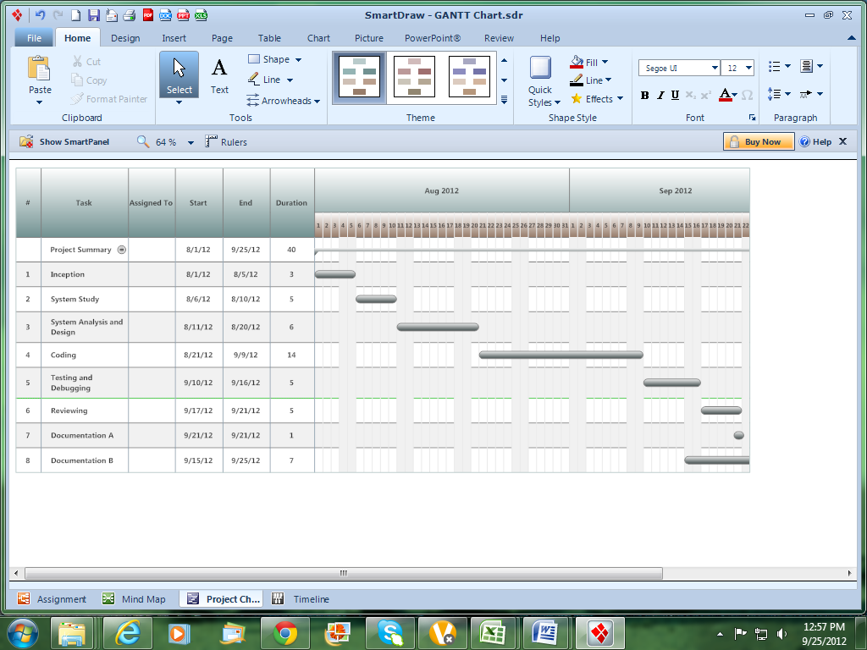
Total Duration: The assignment has been completed in 2 months.

Chapter III
System Design

3.1 Introduction

Design is the first step in the development phase for any techniques and principles for the purpose of defining a device, a process or system in sufficient detail to permit its physical realization.

Once the software requirements have been analyzed and specified the software design involves three technical activities - design, coding, implementation and testing that are required to build and verify the software.

The design activities are of main importance in this phase, because in this activity, decisions ultimately affecting the success of the software implementation and its ease of maintenance are made. These decisions have the final bearing upon reliability and maintainability of the system. Design is the only way to accurately translate the customer’s requirements into finished software or a system.

Design is the place where quality is fostered in development. Software design is a process through which requirements are translated into a representation of software. Software design is conducted in two steps. Preliminary design is concerned with the transformation of requirements into data.

  - Diagram

UML DIAGRAMS:

Actor:
A coherent set of roles that users of use cases play when interacting with the use cases.

Use case:
A description of sequence of actions, including variants, that a system performs that yields an observable result of value of an actor.

UML stands for Unified Modeling Language. UML is a language for specifying, visualizing and documenting the system. This is the step while developing any product after analysis. The goal from this is to produce a model of the entities involved in the project which later need to be built. The representation of the entities that are to be used in the product being developed need to be designed.
There are various kinds of methods in software design:
They are as follows:
- Use case Diagram
- Sequence Diagram
- Collaboration Diagram
- Activity Diagram
- State chat Diagram

Use Case Diagram:

Use case diagrams model behavior within a system and helps the developers understand of what the user require. The stick man represents what’s called an actor. Use case diagram can be useful for getting an overall view of the system and clarifying who can do and more importantly what they can’t do. Use case diagram consists of use cases and actors and shows the interaction between the use case and actors.

- The purpose is to show the interactions between the use case and actor.
- To represent the system requirements from user’s perspective.
- An actor could be the end-user of the system or an external system.

A Use case is a description of set of sequence of actions. Graphically it is rendered as an ellipse with solid line including only its name. Use case diagram is a behavioral diagram that shows a set of use cases and actors and their relationship. It is an association between the use cases and actors. An actor represents a real-world object. Primary Actor – Sender, Secondary ActorReceiver.

Use Case Diagram:

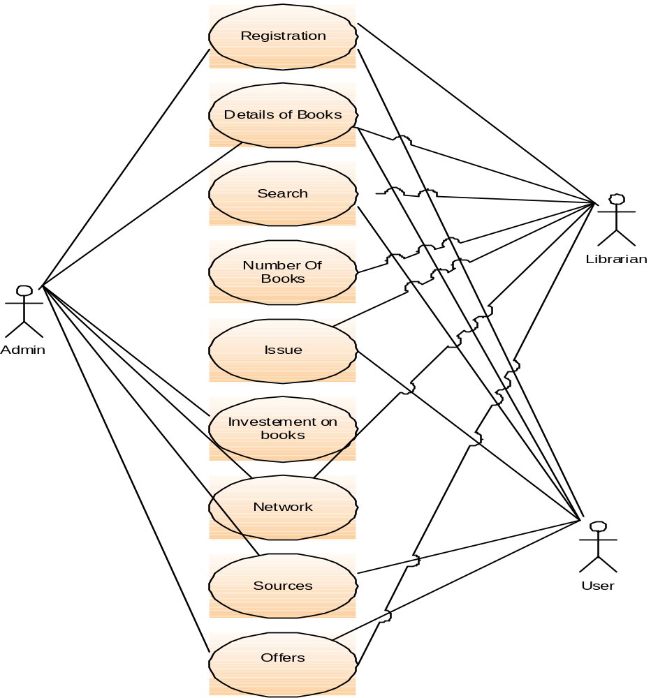

Sequence Diagram:

Sequence diagram and collaboration diagram are called INTERACTION DIAGRAMS. An interaction diagram shows an interaction, consisting of set of objects and their relationship including the messages that may be dispatched among them.
A sequence diagram is an introduction that empathizes the time ordering of messages. Graphically a sequence diagram is a table that shows objects arranged along the X-axis and messages ordered in increasing time along the Y-axis

Sequence Diagram:

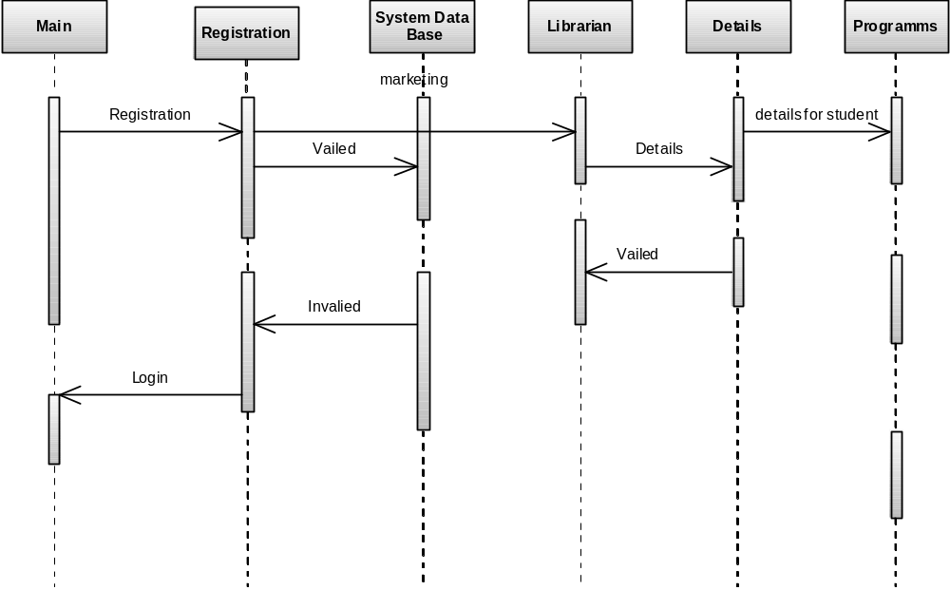

State diagram:

A state diagram is a type of diagram used in computer science and related fields to describe the behavior of systems. State diagrams require that the system described is composed of a finite number of states; sometimes, this is indeed the case, while at other times this is a reasonable abstraction. There are many forms of state diagrams, which differ slightly and have different semantics.

State diagrams are used to give an abstract description of the behavior of a system. This behavior is analyzed and represented in series of events, that could occur in one or more possible states. Hereby "each diagram usually represents objects of a single class and track the different states of its objects through the system".

State Diagram:
user registration
Checking for valid use
Library
user validation
valid user
not valid user

DATA FLOW DIAGRAMS:

The DFD takes an input-process-output view of a system i.e. data objects flow into the software, are transformed by processing elements, and resultant data objects flow out of the software.

Data objects represented by labeled arrows and transformation are represented by circles also called as bubbles. DFD is presented in a hierarchical fashion i.e. the first data flow model represents the system as a whole. Subsequent DFD refine the context diagram (level 0 DFD), providing increasing details with each subsequent level.

The DFD enables the software engineer to develop models of the information domain & functional domain at the same time. As the DFD is refined into greater levels of details, the analyst perform an implicit functional decomposition of the system. At the same time, the DFD refinement results in a corresponding refinement of the data as it moves through the process that embody the applications.

A context-level DFD for the system the primary external entities produce information for use by the system and consume information generated by the system. The labeled arrow represents data objects or object hierarchy.

RULES FOR DFD:

- Fix the scope of the system by means of context diagrams.
- Organize the DFD so that the main sequence of the actions
- Reads left to right and top to bottom.
- Identify all inputs and outputs.
- Identify and label each process internal to the system with Rounded circles.
- A process is required for all the data transformation and Transfers. Therefore, never connect a data store to a data Source or the destinations or another data store with just a Data flow arrow.
- Do not indicate hardware and ignore control information.
- Make sure the names of the processes accurately convey everything the process is done.
- There must not be unnamed process.
- Indicate external sources and destinations of the data, with Squares.
- Number each occurrence of repeated external entities.
- Identify all data flows for each process step, except simple Record retrievals.
- Label data flow on each arrow.
- Use details flow on each arrow.
- Use the details flow arrow to indicate data movements.

E-R Diagrams:
The Entity-Relationship (ER) model was originally proposed by Peter in 1976 [Chen76] as a way to unify the network and relational database views. Simply stated the ER model is a conceptual data model that views the real world as entities and relationships. A basic component of the model is the Entity-Relationship diagram which is used to visually represents data objects. Since Chen wrote his paper the model has been extended and today it is commonly used for database design For the database designer, the utility of the ER model is:
- it maps well to the relational model. The constructs used in the ER model can easily be transformed into relational tables.
- it is simple and easy to understand with a minimum of training. Therefore, the model can be used by the database designer to communicate the design to the end user.
- In addition, the model can be used as a design plan by the database developer to implement a data model in a specific database management software.

Connectivity and Cardinality
The basic types of connectivity for relations are: one-to-one, one-to-many, and many-to-many. A one-to-one (1:1) relationship is when at most one instance of a entity A is associated with one instance of entity B. For example, "employees in the company are each assigned their own office. For each employee there exists a unique office and for each office there exists a unique employee.
A one-to-many (1:N) relationships is when for one instance of entity A, there are zero, one, or many instances of entity B, but for one instance of entity B, there is only one instance of entity A. An example of a 1:N relationships is a department has many employees each employee is assigned to one department.
A many-to-many (M:N) relationship, sometimes called non-specific, is when for one instance of entity A, there are zero, one, or many instances of entity B and for one instance of entity B there are zero, one, or many instances of entity A. The connectivity of a relationship describes the mapping of associated

ER Notation
There is no standard for representing data objects in ER diagrams. Each modeling methodology uses its own notation. The original notation used by Chen is widely used in academics texts and journals but rarely seen in either CASE tools or publications by non-academics. Today, there are a number of notations used, among the more common are Bachman, crow's foot, and IDEFIX.
All notational styles represent entities as rectangular boxes and relationships as lines connecting boxes. Each style uses a special set of symbols to represent the cardinality of a connection. The notation used in this document is from Martin. The symbols used for the basic ER constructs are:
- entities are represented by labeled rectangles. The label is the name of the entity. Entity names should be singular nouns.
- relationships are represented by a solid line connecting two entities. The name of the relationship is written above the line. Relationship names should be verbs
- attributes, when included, are listed inside the entity rectangle. Attributes which are identifiers are underlined. Attribute names should be singular nouns.
- cardinality of many is represented by a line ending in a crow's foot. If the crow's foot is omitted, the cardinality is one.
- existence is represented by placing a circle or a perpendicular bar on the line. Mandatory existence is shown by the bar (looks like a 1) next to the entity for an instance is required. Optional existence is shown by placing a circle next to the entity that is optional
  - Database Design

Database design is the process of producing a detailed data model of a database. This logical data model contains all the needed logical and physical design choices and physical storage parameters needed to generate a design in a Data Definition Language, which can then be used to create a database. A fully attributed data model contains detailed attributes for each entity.

The term database design can be used to describe many different parts of the design of an overall database system. Principally, and most correctly, it can be thought of as the logical design of the base data structures used to store the data. In the relational model these are the tables and views. In an object database the entities and relationships map directly to object classes and named relationships. However, the term database design could also be used to apply to the overall process of designing, not just the base data structures, but also the forms and queries used as part of the overall database application within the database management system (DBMS).

ADO.NET and accessing the database through applets and ADO.NET API via an intermediate server resulted server resulted in a new type of database model which is different from the client-server model. Based on number of intermediate server through the request should go it is named as single tire, two tire and multi tire architecture

Single Tier
In a single tier the server and client are the same in the sense that a client program that needs information (client) and the source of this type of architecture is also possible in java, in case flat files are used to store the data. However this is useful only in case of small applications. The advantage with this is the simplicity and portability of the application developed.

Server and client

Database

Two Tier (client-server)

In two tier architecture the database resides in one machine and client in different machine they are connected through the network. In this type of architecture a database management takes control of the database and provides access to clients in a network. This software bundle is also called as the server. Software in different machines, requesting for information are called as the clients.

Server

Client

Client

Database

Three Tier and N-Tier

In the three-tier architecture, any number servers can access the database that resides on server. Which in turn serve clients in a network. For example, you want to access the database using java applets, the applet running in some other machine, can send request only to the server from which it is down loaded. For this reason we will need to have a intermediate server which will accept the requests from applets and them to the actual database server. This intermediate server acts as a two-way communication channel also. This is the information or data from the database is passed on to the applet that is requesting it. This can be extended to make n tiers of servers, each server carrying to specific type of request from clients, however in practice only 3 tiers architecture is popular.
DATABASE TABLES:

1.) insertbook
BOOKID | INT,
TITLE | VARCHAR(150),
AUTHOR | VARCHAR(100),
YEARPUBLISHED | VARCHAR(20),
CATEGORY | VARCHAR(100),
PUBLISHER | VARCHAR(100),
EDITION | VARCHAR(50),
COST | VARCHAR(20),
DATEOFENTRY | DATETIME,
LIBRARYCOPY | INT,
STATUS | VARCHAR(20),
CONDITION | VARCHAR(20)

2.) librarybooks

BOOKID | INT NULL,
TITLE | VARCHAR(150) NULL,
AUTHOR | VARCHAR(100) NULL,
YEARPUBLISHED | VARCHAR(20) NULL,
CATEGORY | VARCHAR(100) NULL,
PUBLISHER | VARCHAR(100) NULL,
EDITION | VARCHAR(50) NULL,
COST | VARCHAR(20) NULL,
DATEOFENTRY | DATETIME NULL,
LIBRARYCOPY | INT NULL,
STATUS | VARCHAR(20) NULL,
CONDITION | VARCHAR(20) NULL

3.) issuebook

TRNSID | INT NULL,
ROLLNUMBER | INT NULL,
NAME | VARCHAR(150) NULL,
AGE | INT NULL,
GENDER | VARCHAR(10) NULL,
BRANCH | VARCHAR(10) NULL,
YEAR | INT NULL,
BARTYPE | VARCHAR(15) NULL,
BOOKID | INT NULL,
TITLE | VARCHAR(150) NULL,
AUTHOR | VARCHAR(150) NULL,
CATEGORY | VARCHAR(100) NULL,
EDITION | VARCHAR(20) NULL,
PUBLISHER | VARCHAR(50) NULL,
LIBRARYCOPY | INT NULL,
ISSUEDATE | DATETIME NULL,
DUEBACKBY | DATETIME NULL

  - Modules Description

MODULES USED:-
The proposed system categories and follows these modules to implement

Login component
- Administrator (Head office manager)
- Librarian
- User

Administrator Component
- Administrator

Librarian Manager Component
- Librarian Manager

Student Component
- Books Details
- Issue Details

MODULES DESCRIPSTION:-
User: Using login id and password user can the use Library online where users can search for books and renewal books online. They can recommend for new books by just sending messages to the librarian from any where in the college. They can view the issue and return dates of any book and due they have to pay.
Registration: In the Registration module, user has to register himself by supplying his personal information which gets store in data base which are using as backend. By registering himself user will get his login id and Password so that he can access Library online. Separate Register form should be designed for separate user
(Student, Faculty, Librarian) and separate login has to provided for each user. For example if the users are students then student id should be SH001.

Librarian: Librarian is a person who manages the Library. Librarian has the permission that he can access the database. There are some tasks which are performed by the Librarian like:
- Addition of a new book.
- Modification of the book.
- Deletion of the book.
- Searching of the book.
- Managing User

Chapter IV
Development and Testing

  - Coding (Back End and Front End)
Front-end:
Front end development means the part of the programming language that users see and interact with. C# is used as programming language for the system.
Back-end:
Backend development means the part of the system that isn’t user facing. MS Access, SQL Server 2005, 2008 and Visual Studio 2010 is used in this project as database for data storage for Library Management System.

Microsoft Visual Studio 2010 express is used for C# programming platform in LMS, I have used Microsoft Visual Studio 2010 professional version is used for .Net and SQL server management studion 2008 r2 in LMS development.

  - Testing

Testing is a process of executing a program with the indent of finding an error. Testing is a crucial element of software quality assurance and presents ultimate review of specification, design and coding.
System Testing is an important phase. Testing represents an interesting anomaly for the software. Thus a series of testing are performed for the proposed system before the system is ready for user acceptance testing.
A good test case is one that has a high probability of finding an as undiscovered error. A successful test is one that uncovers an as undiscovered error.
Testing Objectives:
- Testing is a process of executing a program with the intent of finding an error
- A good test case is one that has a probability of finding an as yet undiscovered error
- A successful test is one that uncovers an undiscovered error
Testing Principles:
- All tests should be traceable to end user requirements
- Tests should be planned long before testing begins
- Testing should begin on a small scale and progress towards testing in large
- Exhaustive testing is not possible
- To be most effective testing should be conducted by a independent third party

The primary objective for test case design is to derive a set of tests that has the highest livelihood for uncovering defects in software. To accomplish this objective two different categories of test case design techniques are used. They are
- White box testing.
- Black box testing.

White-box testing:
White box testing focus on the program control structure. Test cases are derived to ensure that all statements in the program have been executed at least once during testing and that all logical conditions have been executed.

Block-box testing:
Black box testing is designed to validate functional requirements without regard to the internal workings of a program. Black box testing mainly focuses on the information domain of the software, deriving test cases by partitioning input and output in a manner that provides through test coverage. Incorrect and missing functions, interface errors, errors in data structures, error in functional logic are the errors falling in this category.
Testing strategies:
A strategy for software testing must accommodate low-level tests that are necessary to verify that all small source code segment has been correctly implemented as well as high-level tests that validate major system functions against customer requirements.
Testing fundamentals:
Testing is a process of executing program with the intent of finding error. A good test case is one that has high probability of finding an undiscovered error. If testing is conducted successfully it uncovers the errors in the software. Testing cannot show the absence of defects, it can only show that software defects present.

Testing Information flow:
Information flow for testing flows the pattern. Two class of input provided to test the process. The software configuration includes a software requirements specification, a design specification and source code.
Test configuration includes test plan and test cases and test tools. Tests are conducted and all the results are evaluated. That is test results are compared with expected results. When erroneous data are uncovered, an error is implied and debugging commences.
Unit testing:
Unit testing is essential for the verification of the code produced during the coding phase and hence the goal is to test the internal logic of the modules. Using the detailed design description as a guide, important paths are tested to uncover errors with in the boundary of the modules. These tests were carried out during the programming stage itself. All units of ViennaSQL were successfully tested.
Integration testing :
Integration testing focuses on unit tested modules and build the program structure that is dictated by the design phase.
System testing:
System testing tests the integration of each module in the system. It also tests to find discrepancies between the system and it’s original objective, current specification and system documentation. The primary concern is the compatibility of individual modules. Entire system is working properly or not will be tested here, and specified path ODBC connection will correct or not, and giving output or not are tested here these verifications and validations are done by giving input values to the system and by comparing with expected output. Top-down testing implementing here.

Acceptance Testing:
This testing is done to verify the readiness of the system for the implementation. Acceptance testing begins when the system is complete. Its purpose is to provide the end user with the confidence that the system is ready for use. It involves planning and execution of functional tests, performance tests and stress tests in order to demonstrate that the implemented system satisfies its requirements.
Tools to special importance during acceptance testing include:
Test coverage Analyzer – records the control paths followed for each test case.
Timing Analyzer – also called a profiler, reports the time spent in various regions of the code are areas to concentrate on to improve system performance.
Coding standards – static analyzers and standard checkers are used to inspect code for deviations from standards and guidelines.
Test Cases:
Test cases are derived to ensure that all statements in the program have been executed at least once during testing and that all logical conditions have been executed.
Using White-Box testing methods, the software engineer can drive test cases that
- Guarantee that logical decisions on their true and false sides.
- Exercise all logical decisions on their true and false sides.
- Execute all loops at their boundaries and with in their operational bounds.
- Exercise internal data structure to assure their validity.
The test case specification for system testing has to be submitted for review before system testing commences.

Chapter V
Support
5.1 Implement Plan

Implementation is the stage where the theoretical design is turned into a working system. The most crucial stage in achieving a new successful system and in giving confidence on the new system for the users that it will work efficiently and effectively. The system can be implemented only after thorough testing is done and if it is found to work according to the specification. It involves careful planning, investigation of the current system and its constraints on implementation, design of methods to achieve the change over and an evaluation of change over methods a part from planning. Two major tasks of preparing the implementation are education and training of the users and testing of the system.

The more complex the system being implemented, the more involved will be the systems analysis and design effort required just for implementation. The implementation phase comprises of several activities. The required hardware and software acquisition is carried out. The system may require some software to be developed. For this, programs are written and tested. The user then changes over to his new fully tested system and the old system is discontinued.

  - Maintenance

AS the number of computer based systems, grieve libraries of computer software began to expand. In house developed projects produced tones of thousand soft program source statements. Software products purchased from the outside added hundreds of thousands of new statements. A dark cloud appeared on the horizon. All of these programs, all of those source statements-had to be corrected when false were detected, modified as user requirements changed, or adapted to new hardware that was purchased. These activities were collectively called software Maintenance.
The maintenance phase focuses on change that is associated with error correction, adaptations required as the software's environment evolves, and changes due to enhancements brought about by changing customer requirements. Four types of changes are encountered during the maintenance phase.

Correction
Adaptation
Enhancement
Prevention

Correction:

Even with the best quality assurance activities is lightly that the customer will uncover defects in the software. Corrective maintenance changes the software to correct defects.

Maintenance is a set of software Engineering activities that occur after software has been delivered to the customer and put into operation. Software configuration management is a set of tracking and control activities that began when a software project begins and terminates only when the software is taken out of the operation.

We may define maintenance by describing four activities that are undertaken after a program is released for use:

Corrective Maintenance
Adaptive Maintenance
Perfective Maintenance or Enhancement
Preventive Maintenance or reengineering

Only about 20 percent of all maintenance work are spent "fixing mistakes". The remaining 80 percent are spent adapting existing systems to changes in their external environment, making enhancements requested by users, and reengineering an application for use.

ADAPTATION:

Over time, the original environment (E>G., CPU, operating system, business rules, external product characteristics) for which the software was developed is likely to change. Adaptive maintenance results in modification to the software to accommodate change to its external environment.

ENHANCEMENT:

As software is used, the customer/user will recognize additional functions that will provide benefit. Perceptive maintenance extends the software beyond its original function requirements.

PREVENTION:

Computer software deteriorates due to change, and because of this, preventive maintenance, often called software re engineering, must be conducted to enable the software to serve the needs of its end users. In essence, preventive maintenance makes changes to computer programs so that they can be more easily corrected, adapted, and enhanced. Software configuration management (SCM) is an umbrella activity that is applied throughout the software process. SCM activities are developed to
Chapter VI
Conclusion and Future Plan

6.1 Conclusion

The package was designed in such a way that future modifications can be done easily. The following conclusions can be deduced from the development of the project.

  - Library Management System of the entire system improves the efficiency.
  - It provides a friendly graphical user interface which proves to be better when compared to the existing system.
  - It gives appropriate access to the authorized users depending on their permissions.
  - It effectively overcomes the delay in communications.
  - Updating of information becomes so easier.
  - System security, data security and reliability are the striking features.
  - The System has adequate scope for modification in future if it is necessary.

6.2 Future Plan

This application avoids the manual work and the problems concern with it. It is an easy way to obtain the information regarding the various products information that are present in the Library of a particular college.

Well I and my team members have worked hard in order to present an improved website better than the existing one’s regarding the information about the various activities. Still ,we found out that the project can be done in a better way. Primarily, when we request information about a particular product it just shows the company, product id, product name and no. of quantities available. So, after getting the information we can get access to the product company website just by a click on the product name .

The next enhancement that we can add the searching option. We can directly search to the particular product company from this site .These are the two enhancements that we could think of at present.

6.3 Bibliography

The following books were referred during the analysis and execution phase of the project

MICROSOFT .NET WITH C#
Microsoft .net series

ASP .NET 2.0 PROFESSIONAL
Wrox Publishers

ASP .NET WITH C# 2005
Apress Publications

C# COOK BOOK
O reilly Publications

PROGRAMMING MICROSOFT ASP .NET 2.0 APPLICATION
Wrox Professional Guide

BEGINNING ASP .NET 2.0 E-COMMERCE IN C# 2005
Novice to Professional.

WEBSITES:
www.google.com
www.microsoft.com

- Source Code

Pages/ Login. aspx.cs
using System;
using System.Data;
using System.Configuration;
using System.Collections;
using System.Web;
using System.Web.Security;
using System.Web.UI;
using System.Web.UI.WebControls;
using System.Web.UI.WebControls.WebParts;
using System.Web.UI.HtmlControls;
using System.Data.SqlClient;

public partial class Login : System.Web.UI.Page
{
protected void Page_Load(object sender, EventArgs e)
{

}
protected void LoginButton_Click(object sender, EventArgs e)
{
try
{
string strRole;

string sql = "SELECT MEMBER_ID, USER_NAME, PASSWORD, FIRST_NAME, MIDDLE_NAME, LAST_NAME, STATUS, USER_TYPE FROM MEMBER WHERE USER_NAME = '" + UserName.Text + "' AND PASSWORD = '" + Password.Text + "'";
SqlDataReader sdr;

Profile pro = new Profile();
sdr = pro.ReturnMDetails(sql);
if (sdr.Read() == true)
{
FormsAuthentication.Initialize();
if(sdr["USER_TYPE"].ToString().Trim() == "A")
{
strRole = "Admin";
}
else
{
strRole = "Member";
}

//The AddMinutes determines how long the user will be logged in after leaving
//the site if he doesn't log off.
//FormsAuthenticationTicket fat = new FormsAuthenticationTicket(1, UserName.Text, DateTime.Now,
// DateTime.Now.AddMinutes(30), false, strRole, FormsAuthentication.FormsCookiePath);

//Response.Cookies.Add(new HttpCookie(FormsAuthentication.FormsCookieName,
// FormsAuthentication.Encrypt(fat)));

Session["MEMBER_ID"] = sdr["MEMBER_ID"].ToString().Trim();
Session["USER_NAME"] = sdr["USER_NAME"].ToString().Trim();
Session["PASSWORD"] = sdr["PASSWORD"].ToString().Trim();
Session["NAME"] = sdr["FIRST_NAME"].ToString().Trim() + " " + sdr["MIDDLE_NAME"].ToString().Trim() + " " + sdr["LAST_NAME"].ToString().Trim();
Session["STATUS"] = sdr["STATUS"].ToString().Trim();
Session["USER_TYPE"] = sdr["USER_TYPE"].ToString().Trim();
//Response.Redirect(FormsAuthentication.GetRedirectUrl("Home.aspx", false));
Response.Redirect("Home.aspx");
}
else
{
lblErrorMsg.Visible = true;
lblErrorMsg.Text = "Invalid User Name/Password.";
}
sdr.Close();
}
catch(Exception err)
{
lblErrorMsg.Visible = true;
lblErrorMsg.Text = err.Message;
}
}
}

Pages/ Home. aspx.cs:
using System;
using System.Data;
using System.Configuration;
using System.Collections;
using System.Web;
using System.Web.Security;
using System.Web.UI;
using System.Web.UI.WebControls;
using System.Web.UI.WebControls.WebParts;
using System.Web.UI.HtmlControls;

public partial class Home : System.Web.UI.Page
{
protected void Page_Load(object sender, EventArgs e)
{
if (Session["USER_TYPE"] == null)
{
Response.Redirect("Logout.aspx");
}

if (Session["USER_TYPE"].ToString() == "A")
{
Panel2.Visible = false;
lblName.Text = (string)Session["USER_NAME"].ToString();
}
else
{
Panel3.Visible = false;
//HSMember.Visible = false;
lblName.Text = (string)Session["NAME"].ToString();
}
}

}

Pages/Member. aspx.cs:
using System;
using System.Data;
using System.Configuration;
using System.Collections;
using System.Web;
using System.Web.Security;
using System.Web.UI;
using System.Web.UI.WebControls;
using System.Web.UI.WebControls.WebParts;
using System.Web.UI.HtmlControls;
//using System.Data;
using System.Data.SqlClient;

public partial class Member : System.Web.UI.Page
{
protected void Page_Load(object sender, EventArgs e)
{
if (Page.IsPostBack == false)
{
try
{
string sql = "SELECT COUNT(*) FROM MEMBER";
SqlDataReader sdr;
Profile pro = new Profile();
sdr = pro.ReturnMDetails(sql);

sdr.Read();
int RegNo = (int)sdr[0] + 1;
if (RegNo < 10)
{
txtReg.Text = string.Format("M000{0}", RegNo);
}
else if (RegNo > 10 && RegNo < 100)
{
txtReg.Text = string.Format("M00{0}", RegNo);
}
else
{
txtReg.Text = string.Format("M0{0}", RegNo);
}
sdr.Close();
return;
}
catch (Exception ex)
{
throw ex;
}
}
}

protected void btnClear_Click(object sender, EventArgs e)
{
UserName.Text = "";
Password.Text = "";
ConfirmPassword.Text = "";
txtFName.Text = "";
txtMName.Text = "";
txtLName.Text = "";
txtAddress.Text = "";
Email.Text = "";
txtLline.Text = "";
txtMobile.Text = "";
optMale.Checked = true;
optFemale.Checked = false;
Question.Text = "";
Answer.Text = "";
}
protected void btnSignUp_Click(object sender, EventArgs e)
{
try
{
string[] MProfile;
lblEMsg.Visible = false;

string sql = "SELECT COUNT(*) FROM MEMBER WHERE USER_NAME = '" + UserName.Text + "'";
SqlDataReader sdr;
Profile pro = new Profile();
sdr = pro.ReturnMDetails(sql);

sdr.Read();
int RegNo = (int)sdr[0];
if (RegNo > 0)
{
lblEMsg.Text = "User account already exists";
lblEMsg.Visible = true;
sdr.Close();
return;
}
sdr.Close();

sql = "SELECT COUNT(*) FROM MEMBER";
sdr = pro.ReturnMDetails(sql);
sdr.Read();
RegNo = (int)sdr[0] + 1;
if (RegNo < 10)
{
txtReg.Text = string.Format("M000{0}", RegNo);
}
else if (RegNo > 10 && RegNo < 100)
{
txtReg.Text = string.Format("M00{0}", RegNo);
}
else
{
txtReg.Text = string.Format("M0{0}", RegNo);
}
sdr.Close();

MProfile = new string[15];

MProfile[0] = txtReg.Text;
MProfile[1] = UserName.Text;
MProfile[2] = Password.Text;
MProfile[3] = txtFName.Text;
MProfile[4] = txtMName.Text;
MProfile[5] = txtLName.Text;
MProfile[6] = txtAddress.Text;
MProfile[7] = Email.Text;
MProfile[8] = txtLline.Text;
MProfile[9] = txtMobile.Text;
if (optMale.Checked == true)
{
MProfile[10] = "M";
}
else
{
MProfile[10] = "F";
}
MProfile[11] = Question.Text;
MProfile[12] = Answer.Text;
MProfile[13] = "A";
MProfile[14] = "M";

bool status;
status = pro.AddProfile(MProfile);

if (status == false)
{
lblEMsg.Visible = true;
lblEMsg.Text = "User creation Failed";
}
else
{
Session["MEMBER_ID"] = MProfile[0];
Session["USER_NAME"] = MProfile[1];
Session["PASSWORD"] = MProfile[2];
Session["NAME"] = MProfile[3] + " " + MProfile[4] + " " + MProfile[5];
Session["STATUS"] = MProfile[13];
Session["USER_TYPE"] = MProfile[14];
Response.Redirect("Home.aspx");
return;
}
}
catch (Exception ex)
{
throw ex;
}
}
}

Pages/Search. aspx.cs:
using System;
using System.Data;
using System.Configuration;
using System.Collections;
using System.Web;
using System.Web.Security;
using System.Web.UI;
using System.Web.UI.WebControls;
using System.Web.UI.WebControls.WebParts;
using System.Web.UI.HtmlControls;
using System.Data.SqlClient;

public partial class Search : System.Web.UI.Page
{
protected void Page_Load(object sender, EventArgs e)
{
if (Session["USER_TYPE"] == null)
{
Response.Redirect("Logout.aspx");
}
if (Page.IsPostBack == false)
{
if (Session["USER_TYPE"].ToString() == "A")
{
Panel2.Visible = false;
}
else
{
Panel3.Visible = false;
}
try
{

string sql = "SELECT Distinct Book_Title FROM Book_Master Where Status = 'A'";
SqlDataReader sdr;
Profile pro = new Profile();
sdr = pro.ReturnMDetails(sql);
lstBook.Items.Clear();
lstBook.Items.Add("");
while (sdr.Read())
{
lstBook.Items.Add(sdr["Book_Title"].ToString().Trim());
}
sdr.Close();

sql = "SELECT DISTINCT BM.BOOK_ID AS 'Book ID', BM.BOOK_TITLE AS 'Book Title', A.AUTHOR_NAME AS 'Author Name', P.PUBLISHER_NAME AS 'Pulisher Name', ";
sql = sql + "P.PUBLISHING_YEAR AS 'Publishing Year', P.PUBLISHING_HOUSE AS 'Publishing House', P.PUBLISHER_EDITION AS 'Publisher Edition', C.CATEGORY_NAME AS 'Category Name', ";
sql = sql + "S.SUPPLIER_NAME AS 'Supplier Name', BM.ISBN, BM.PRICE FROM BOOK_MASTER BM INNER JOIN AUTHOR A ON BM.AUTHOR_ID = A.AUTHOR_ID ";
sql = sql + "INNER JOIN PUBLISHER P ON BM.PUBLISHER_ID = P.PUBLISHER_ID INNER JOIN CATEGORY C ON BM.CATEGORY_ID = C.CATEGORY_ID ";
sql = sql + "INNER JOIN SUPPLIER S ON BM.SUPPLIER_ID = S.SUPPLIER_ID WHERE BM.BOOK_TITLE IS NULL ORDER BY BM.BOOK_ID";

ReadBook(sql);
}
catch (Exception ex)
{
throw ex;
}
}
}
protected void lstBook_SelectedIndexChanged(object sender, EventArgs e)
{
try
{
string sql = "SELECT DISTINCT BM.BOOK_ID AS 'Book ID', BM.BOOK_TITLE AS 'Book Title', A.AUTHOR_NAME AS 'Author Name', P.PUBLISHER_NAME AS 'Pulisher Name', ";
sql = sql + "P.PUBLISHING_YEAR AS 'Publishing Year', P.PUBLISHING_HOUSE AS 'Publishing House', P.PUBLISHER_EDITION AS 'Publisher Edition', C.CATEGORY_NAME AS 'Category Name', ";
sql = sql + "S.SUPPLIER_NAME AS 'Supplier Name', BM.ISBN, BM.PRICE FROM BOOK_MASTER BM INNER JOIN AUTHOR A ON BM.AUTHOR_ID = A.AUTHOR_ID ";
sql = sql + "INNER JOIN PUBLISHER P ON BM.PUBLISHER_ID = P.PUBLISHER_ID INNER JOIN CATEGORY C ON BM.CATEGORY_ID = C.CATEGORY_ID ";
sql = sql + "INNER JOIN SUPPLIER S ON BM.SUPPLIER_ID = S.SUPPLIER_ID WHERE BM.BOOK_TITLE = '" + lstBook.SelectedItem.Text + "' ORDER BY BM.BOOK_ID";

ReadBook(sql);
}
catch (Exception ex)
{
throw ex;
}
}

private void ReadBook(string sql)
{
try
{
string connStr = ConfigurationManager.ConnectionStrings["LibraryConn"].ToString();
SqlConnection conn = new SqlConnection(connStr);

SqlCommand cmd = new SqlCommand(sql, conn);
SqlDataAdapter adp = new SqlDataAdapter(cmd);

//Fill Dataet
DataSet ds = new DataSet();
adp.Fill(ds, "Book_Transaction");

gvBook.DataSource = ds;
gvBook.DataBind();

adp.Dispose();
cmd.Cancel();
conn.Close();
}
catch (Exception ex)
{
throw ex;
}
}
}

Pages/IssueBook. aspx.cs:
using System;
using System.Data;
using System.Configuration;
using System.Collections;
using System.Web;
using System.Web.Security;
using System.Web.UI;
using System.Web.UI.WebControls;
using System.Web.UI.WebControls.WebParts;
using System.Web.UI.HtmlControls;
using System.Data.SqlClient;

public partial class IssueBook : System.Web.UI.Page
{
bool status = false;
protected void Page_Load(object sender, EventArgs e)
{
if (Session["USER_TYPE"] == null)
{
Response.Redirect("Logout.aspx");
}
if (Page.IsPostBack == false)
{
ReadBook();
txtIDate.Text = DateTime.Now.ToShortDateString();
if (Session["USER_TYPE"].ToString() == "A")
{
Panel2.Visible = false;
}
else
{
Panel3.Visible = false;
//HSMember.Visible = false;
}
}
}

protected void LstBook_SelectedIndexChanged(object sender, EventArgs e)
{
lblEMsg.Visible = false;
/*if (status == false)
{
btnGo_Click(sender, e);
status = true;
}*/
//if (Page.IsPostBack == false)
//{
try
{
status = true;
string Author, Publisher, Category, Supplier;
int AQuantity = 0;

if (LstBook.SelectedItem.ToString() == "")
{
lblEMsg.Visible = true;
lblEMsg.Text = "Please select the Book";
return;
}
string sql = "SELECT Book_Title, Author_ID, Publisher_ID, Category_ID, Supplier_ID, Quantity, Price FROM Book_Master WHERE Book_ID = '" + LstBook.SelectedItem.ToString() + "' And Status = 'A'";
SqlDataReader sdr;
Profile pro = new Profile();
sdr = pro.ReturnMDetails(sql);

if (sdr.Read() == true)
{
txtBTitle.Text = sdr["Book_Title"].ToString().Trim();

Author = sdr["Author_ID"].ToString().Trim();
Publisher = sdr["Publisher_ID"].ToString().Trim();
Category = sdr["Category_ID"].ToString().Trim();
Supplier = sdr["Supplier_ID"].ToString().Trim();

AQuantity = Convert.ToInt32(sdr["Quantity"]);
txtPrice.Text = sdr["Price"].ToString().Trim();

//Get Author Name.
sql = "Select Distinct Author_Name From Author Where Author_ID = '" + Author + "'";
sdr = pro.ReturnMDetails(sql);
if (sdr.Read() == true)
{
txtAuthor.Text = sdr["Author_Name"].ToString().Trim();
}
//sdr.Close;

//Get Publisher_Name
sql = "Select Distinct Publisher_Name From Publisher Where Publisher_ID = '" + Publisher + "'";
sdr = pro.ReturnMDetails(sql);
if (sdr.Read() == true)
{
txtPub.Text = sdr["Publisher_Name"].ToString().Trim();
}
//sdr.Close;

//Get Category Name
sql = "Select Distinct Category_Name From Category Where Category_ID = '" + Category + "'";
sdr = pro.ReturnMDetails(sql);
if (sdr.Read() == true)
{
txtCat.Text = sdr["Category_Name"].ToString().Trim();
}
//sdr.Close;

//Get Supplier Name
sql = "Select Distinct Supplier_Name From Supplier Where Supplier_ID = '" + Supplier + "'";
sdr = pro.ReturnMDetails(sql);
if (sdr.Read() == true)
{
txtSup.Text = sdr["Supplier_Name"].ToString().Trim();
}
//sdr.Close;

sql = "Select Count(1) From Book_Transaction Where Book_ID = '" + LstBook.SelectedItem.Text + "' And Actual_Return_Date Is Null";
sdr = pro.ReturnMDetails(sql);
if (sdr.Read() == true)
{
AQuantity -= (int)sdr[0];
}
}
sdr.Close();
txtQuantity.Text = Convert.ToString(AQuantity);
return;
}
catch (NullReferenceException nex)
{
lblEMsg.Visible = true;
lblEMsg.Text = "Please select the Book";
return;
}
catch (Exception ex)
{
throw ex;
}
// }
}
protected void btnGo_Click(object sender, EventArgs e)
{

}
protected void btnClear_Click(object sender, EventArgs e)
{
DropDownList1.Text = "";
LstBook.Text = "";
txtBTitle.Text = "";
txtAuthor.Text = "";
txtPub.Text = "";
txtCat.Text = "";
txtSup.Text = "";
txtQuantity.Text = "";
txtPrice.Text = "";
txtRDate.Text = "";
Label9.Text = "";
}
protected void btnCal_Click(object sender, EventArgs e)
{
//btnCal.Visible = false;
Calendar1.Visible = true;
}
protected void Calendar1_SelectionChanged(object sender, EventArgs e)
{
lblEMsg.Visible = false;
if (Convert.ToDateTime(txtIDate.Text) > Convert.ToDateTime(Calendar1.SelectedDate.ToString()))
{
lblEMsg.Visible = true;
lblEMsg.Text = "Return date should be greater then Issue Date.";
return;
}
txtRDate.Text = Calendar1.SelectedDate.ToShortDateString();
Calendar1.Visible = false;
//btnIssue.Focus();
}
private void ReadBook()
{
try
{
SqlDataReader sdr;
Profile pro = new Profile();

string sql = "SELECT Distinct Member_ID FROM Member where Status = 'A'";
sdr = pro.ReturnMDetails(sql);

DropDownList1.Items.Add("");
while (sdr.Read())
{
DropDownList1.Items.Add(sdr["Member_ID"].ToString().Trim());
}
sdr.Close();

sql = "SELECT Distinct Book_ID FROM Book_Master where Status = 'A'";
sdr = pro.ReturnMDetails(sql);

LstBook.Items.Add("");
while (sdr.Read() )
{
LstBook.Items.Add(sdr["Book_ID"].ToString().Trim());
}
sdr.Close();
}
catch (Exception ex)
{
throw ex;
}
}
protected void DropDownList1_SelectedIndexChanged(object sender, EventArgs e)
{
lblEMsg.Visible = false;
Label9.Visible = false;
try
{
if (DropDownList1.SelectedItem.ToString() == "")
{
lblEMsg.Visible = true;
lblEMsg.Text = "Please select the Member";
return;
}
string sql = "SELECT First_Name, Middle_Name, Last_Name FROM Member WHERE Member_ID = '" + DropDownList1.SelectedItem.ToString() + "' And Status = 'A'";
SqlDataReader sdr;
Profile pro = new Profile();
sdr = pro.ReturnMDetails(sql);
if (sdr.Read() == true)
{
Label9.Visible = true;
Label9.Text = sdr["First_Name"].ToString().Trim() + " " + sdr["Middle_Name"].ToString().Trim() + " " + sdr["Last_Name"].ToString().Trim();
}
sdr.Close();
return;
}
catch (NullReferenceException nex)
{
lblEMsg.Visible = true;
lblEMsg.Text = "Please select the Member";
return;
}
catch (Exception ex)
{
throw ex;
}
}
protected void btnIssue_Click(object sender, EventArgs e)
{
lblEMsg.Visible = false;
string[] iBook;
try
{
SqlDataReader sdr;
Profile pro = new Profile();

int aQty = Convert.ToInt32(txtQuantity.Text.ToString());
if (aQty == 0)
{
lblEMsg.Visible = true;
lblEMsg.Text = "This book is Out of stock, please select a different book.";
return;
}

string sql = "SELECT Count(1) FROM Book_Transaction WHERE Book_ID = '" + LstBook.SelectedItem.Text + "' And Member_ID = '" + DropDownList1.SelectedItem.Text + "' And Actual_Return_Date Is Null";
sdr = pro.ReturnMDetails(sql);
sdr.Read();
int iB = (int)sdr[0];
if (iB > 0)
{
lblEMsg.Visible = true;
lblEMsg.Text = "This book is already issued, please select a different book.";
return;
}
sdr.Close();

//Insert the data.
iBook = new string[4];

iBook[0] = LstBook.SelectedItem.Text;
iBook[1] = DropDownList1.SelectedItem.Text;
iBook[2] = txtIDate.Text;
iBook[3] = txtRDate.Text;

bool status;
status = pro.IssueBook(iBook);

if (status == false)
{
lblEMsg.Visible = true;
lblEMsg.Text = "Book Issuing Failed";
}
lblEMsg.Visible = true;
lblEMsg.Text = "Book Issued.";
DropDownList1.Text = "";
LstBook.Text = "";
txtBTitle.Text = "";
txtAuthor.Text = "";
txtPub.Text = "";
txtCat.Text = "";
txtSup.Text = "";
txtQuantity.Text = "";
txtPrice.Text = "";
txtRDate.Text = "";
Label9.Text = "";
return;
}
catch (Exception ex)
{
lblEMsg.Visible = true;
lblEMsg.Text = ex.Message;
}

}
}

Pages/ReturnBook. aspx.cs:
using System;
using System.Data;
using System.Configuration;
using System.Collections;
using System.Web;
using System.Web.Security;
using System.Web.UI;
using System.Web.UI.WebControls;
using System.Web.UI.WebControls.WebParts;
using System.Web.UI.HtmlControls;
using System.Data.SqlClient;

public partial class ReceiptBook : System.Web.UI.Page
{
protected void Page_Load(object sender, EventArgs e)
{
if (Session["USER_TYPE"] == null)
{
Response.Redirect("Logout.aspx");
}
if (Page.IsPostBack == false)
{
ReadBook();
txtARDate.Text = DateTime.Now.ToShortDateString();
if (Session["USER_TYPE"].ToString() == "A")
{
Panel2.Visible = false;
}
else
{
Panel3.Visible = false;
}
}
}

protected void LstBook_SelectedIndexChanged(object sender, EventArgs e)
{
lblEMsg.Visible = false;
try
{
string Author, Publisher, Category, Supplier;

if (LstBook.SelectedItem.ToString() == "")
{
lblEMsg.Visible = true;
lblEMsg.Text = "Please select the Book";
return;
}
string sql = "SELECT Book_Title, Author_ID, Publisher_ID, Category_ID, Supplier_ID FROM Book_Master WHERE Book_ID = '" + LstBook.SelectedItem.ToString() + "' And Status = 'A'";
SqlDataReader sdr;
Profile pro = new Profile();
sdr = pro.ReturnMDetails(sql);

if (sdr.Read() == true)
{
txtBTitle.Text = sdr["Book_Title"].ToString().Trim();

Author = sdr["Author_ID"].ToString().Trim();
Publisher = sdr["Publisher_ID"].ToString().Trim();
Category = sdr["Category_ID"].ToString().Trim();
Supplier = sdr["Supplier_ID"].ToString().Trim();

//Get Author Name.
sql = "Select Distinct Author_Name From Author Where Author_ID = '" + Author + "'";
sdr = pro.ReturnMDetails(sql);
if (sdr.Read() == true)
{
txtAuthor.Text = sdr["Author_Name"].ToString().Trim();
}
//sdr.Close;

//Get Publisher_Name
sql = "Select Distinct Publisher_Name From Publisher Where Publisher_ID = '" + Publisher + "'";
sdr = pro.ReturnMDetails(sql);
if (sdr.Read() == true)
{
txtPub.Text = sdr["Publisher_Name"].ToString().Trim();
}
//sdr.Close;

//Get Category Name
sql = "Select Distinct Category_Name From Category Where Category_ID = '" + Category + "'";
sdr = pro.ReturnMDetails(sql);
if (sdr.Read() == true)
{
txtCat.Text = sdr["Category_Name"].ToString().Trim();
}

//Get Supplier Name
sql = "Select Distinct Supplier_Name From Supplier Where Supplier_ID = '" + Supplier + "'";
sdr = pro.ReturnMDetails(sql);
if (sdr.Read() == true)
{
txtSup.Text = sdr["Supplier_Name"].ToString().Trim();
}
}
sdr.Close();

//Get Issue Date & Return Date.
DateTime rDate, arDate;
sql = "SELECT Issue_Date, Return_Date FROM Book_Transaction WHERE Member_ID = '" + lstMember.SelectedItem.ToString() + "' And Book_ID = '" + LstBook.SelectedItem.Text + "' And Actual_Return_Date is Null";
sdr = pro.ReturnMDetails(sql);
if (sdr.Read() == true)
{
txtIDate.Text = sdr["Issue_Date"].ToString().Trim();
txtRDate.Text = sdr["Return_Date"].ToString().Trim();
rDate = Convert.ToDateTime(sdr["Return_Date"].ToString().Trim());

arDate = Convert.ToDateTime(txtARDate.Text);
if (rDate < arDate)
{

TimeSpan dDiff;
dDiff = arDate.Subtract(rDate);
txtLFee.Text = Convert.ToString(Convert.ToInt32(dDiff.Days) * 10);
}
else
{
txtLFee.Text = "0";
}
}
sdr.Close();

//Check if any book is issued for this member.
sql = "SELECT Count(1) FROM Book_Transaction WHERE Member_ID = '" + lstMember.SelectedItem.ToString() + "' And Book_ID = '" + LstBook.SelectedItem.Text + "' And Actual_Return_Date is Null";
sdr = pro.ReturnMDetails(sql);
sdr.Read();
int iB = (int)sdr[0];
if (iB == 0)
{
lblEMsg.Visible = true;
lblEMsg.Text = "No Book is issued for this member, please select the correct member";
return;
}
sdr.Close();
return;
}
catch (NullReferenceException nex)
{
lblEMsg.Visible = true;
lblEMsg.Text = "Please select the Book";
return;
}
catch (Exception ex)
{
throw ex;
}

}
protected void btnClear_Click(object sender, EventArgs e)
{
lstMember.Text = "";
LstBook.Text = "";
txtBTitle.Text = "";
txtAuthor.Text = "";
txtPub.Text = "";
txtCat.Text = "";
txtSup.Text = "";
txtIDate.Text = "";
txtRDate.Text = "";
lblName.Text = "";
lblEMsg.Text = "";
}
protected void lstMember_SelectedIndexChanged(object sender, EventArgs e)
{
lblEMsg.Visible = false;
lblName.Visible = false;
try
{
if (lstMember.SelectedItem.ToString() == "")
{
lblEMsg.Visible = true;
lblEMsg.Text = "Please select the Member";
return;
}
string sql = "SELECT First_Name, Middle_Name, Last_Name FROM Member WHERE Member_ID = '" + lstMember.SelectedItem.ToString() + "' And Status = 'A'";
SqlDataReader sdr;
Profile pro = new Profile();
sdr = pro.ReturnMDetails(sql);
if (sdr.Read() == true)
{
lblName.Visible = true;
lblName.Text = sdr["First_Name"].ToString().Trim() + " " + sdr["Middle_Name"].ToString().Trim() + " " + sdr["Last_Name"].ToString().Trim();
}
sdr.Close();

//Check if any book is issued for this member.
sql = "SELECT Count(1) FROM Book_Transaction WHERE Member_ID = '" + lstMember.SelectedItem.ToString() + "' And Actual_Return_Date is Null";
sdr = pro.ReturnMDetails(sql);
sdr.Read();
int iB = (int)sdr[0];
if (iB == 0)
{
lblEMsg.Visible = true;
lblEMsg.Text = "No Book is issued for this member, please select the correct member";
lstMember.Text = "";
lblName.Text = "";
return;
}
sdr.Close();
return;
}
catch (NullReferenceException nex)
{
lblEMsg.Visible = true;
lblEMsg.Text = "Please select the Member";
return;
}
catch (Exception ex)
{
throw ex;
}
}
private void ReadBook()
{
try
{
SqlDataReader sdr;
Profile pro = new Profile();

string sql = "SELECT Distinct Member_ID FROM Member where Status = 'A'";
sdr = pro.ReturnMDetails(sql);

lstMember.Items.Add("");
while (sdr.Read())
{
lstMember.Items.Add(sdr["Member_ID"].ToString().Trim());
}
sdr.Close();

sql = "SELECT Distinct Book_ID FROM Book_Master where Status = 'A'";
sdr = pro.ReturnMDetails(sql);

LstBook.Items.Add("");
while (sdr.Read())
{
LstBook.Items.Add(sdr["Book_ID"].ToString().Trim());
}
sdr.Close();
}
catch (Exception ex)
{
throw ex;
}
}
protected void btnReturn_Click(object sender, EventArgs e)
{
lblEMsg.Visible = false;
string[] iBook;
try
{
SqlDataReader sdr;
Profile pro = new Profile();

//Check if any book is issued for this member.
string sql = "SELECT Count(1) FROM Book_Transaction WHERE Member_ID = '" + lstMember.SelectedItem.ToString() + "' And Book_ID = '" + LstBook.SelectedItem.Text + "' And Actual_Return_Date is Null";
sdr = pro.ReturnMDetails(sql);
sdr.Read();
int iB = (int)sdr[0];
if (iB == 0)
{
lblEMsg.Visible = true;
lblEMsg.Text = "No Book is issued for this member, please select the correct member";
return;
}
sdr.Close();

//Insert the data.
iBook = new string[4];

iBook[0] = LstBook.SelectedItem.Text;
iBook[1] = lstMember.SelectedItem.Text;
iBook[2] = txtARDate.Text;
iBook[3] = txtLFee.Text;

bool status;
status = pro.ReturnBook(iBook);

if (status == false)
{
lblEMsg.Visible = true;
lblEMsg.Text = "Book Returning Failed";
}
lblEMsg.Visible = true;
lblEMsg.Text = "Book Returned.";
lstMember.Text = "";
LstBook.Text = "";
txtBTitle.Text = "";
txtAuthor.Text = "";
txtPub.Text = "";
txtCat.Text = "";
txtSup.Text = "";
txtRDate.Text = "";
txtIDate.Text = "";
lblName.Text = "";
txtLFee.Text = "";
return;
}
catch (Exception ex)
{
lblEMsg.Visible = true;
lblEMsg.Text = ex.Message;
}

}
}

CheckedIn. aspx.cs:
using System;
using System.Data;
using System.Configuration;
using System.Collections;
using System.Web;
using System.Web.Security;
using System.Web.UI;
using System.Web.UI.WebControls;
using System.Web.UI.WebControls.WebParts;
using System.Web.UI.HtmlControls;
using System.Data.SqlClient;

public partial class CheckedIn : System.Web.UI.Page
{
protected void Page_Load(object sender, EventArgs e)
{
if (Session["USER_TYPE"] == null)
{
Response.Redirect("Logout.aspx");
}
if (Page.IsPostBack == false)
{
if (Session["USER_TYPE"].ToString() == "A")
{
Panel2.Visible = false;
}
else
{
Panel3.Visible = false;
}
try
{

string connStr = ConfigurationManager.ConnectionStrings["LibraryConn"].ToString();
SqlConnection conn = new SqlConnection(connStr);

/*string sql = "SELECT DISTINCT BT.BOOK_ID, BM.BOOK_TITLE, A.AUTHOR_NAME, P.PUBLISHER_NAME, P.PUBLISHING_YEAR, P.PUBLISHING_HOUSE, P.PUBLISHER_EDITION, C.CATEGORY_NAME, ";
sql = sql + "S.SUPPLIER_NAME, BT.ISSUE_DATE, BT.RETURN_DATE, BT.ACTUAL_RETURN_DATE, BT.LATE_FEE FROM BOOK_TRANSACTION BT INNER JOIN BOOK_MASTER BM ON BT.BOOK_ID = BM.BOOK_ID ";
sql = sql + "INNER JOIN AUTHOR A ON BM.AUTHOR_ID = A.AUTHOR_ID INNER JOIN PUBLISHER P ON BM.PUBLISHER_ID = P.PUBLISHER_ID INNER JOIN CATEGORY C ON BM.CATEGORY_ID = C.CATEGORY_ID ";
sql = sql + "INNER JOIN SUPPLIER S ON BM.SUPPLIER_ID = S.SUPPLIER_ID WHERE BT.MEMBER_ID = 'M0002' ORDER BY BT.BOOK_ID";*/
string sql = "SELECT DISTINCT BT.BOOK_ID AS 'Book ID', BM.BOOK_TITLE AS 'Book Tite' , A.AUTHOR_NAME AS 'Author Name', ";
sql = sql + "P.PUBLISHER_NAME AS 'Publisher Name', BT.ISSUE_DATE AS 'Issue Date', BT.RETURN_DATE AS 'Return Date', ";
sql = sql + "BT.ACTUAL_RETURN_DATE AS 'Actual Return Date', BT.LATE_FEE AS 'Late Fee' FROM BOOK_TRANSACTION BT INNER JOIN ";
sql = sql + "BOOK_MASTER BM ON BT.BOOK_ID = BM.BOOK_ID INNER JOIN AUTHOR A ON BM.AUTHOR_ID = A.AUTHOR_ID ";
sql = sql + "INNER JOIN PUBLISHER P ON BM.PUBLISHER_ID = P.PUBLISHER_ID WHERE BT.MEMBER_ID = '" + Session["MEMBER_ID"].ToString() + "' ORDER BY BT.BOOK_ID";
SqlCommand cmd = new SqlCommand(sql, conn);
SqlDataAdapter adp = new SqlDataAdapter(cmd);

//Fill Dataet
DataSet ds = new DataSet();
adp.Fill(ds, "Book_Transaction");

gvBook.DataSource = ds;
gvBook.DataBind();

adp.Dispose();
cmd.Cancel();
conn.Close();

}
catch (Exception ex)
{
throw ex;
}
}
}
}
Pages/AddBook. aspx.cs:
using System;
using System.Data;
using System.Configuration;
using System.Collections;
using System.Web;
using System.Web.Security;
using System.Web.UI;
using System.Web.UI.WebControls;
using System.Web.UI.WebControls.WebParts;
using System.Web.UI.HtmlControls;
using System.Data.SqlClient;

public partial class AddBook : System.Web.UI.Page
{
protected void Page_Load(object sender, EventArgs e)
{
if (Session["USER_TYPE"] == null)
{
Response.Redirect("Logout.aspx");
}

if (Page.IsPostBack == false)
{
ReadBook();

if (Session["USER_TYPE"].ToString() == "A")
{
Panel2.Visible = false;
}
else
{
Panel3.Visible = false;
}
}
}
protected void btnAdd_Click(object sender, EventArgs e)
{
lblEMsg.Visible = false;
string[] Book;
string Author_ID, Publisher_ID, Category_ID, Supplier_ID;
try
{
string sql;
SqlDataReader sdr;
Profile pro = new Profile();

//Retrieve Author ID.
sql = "SELECT Author_ID FROM Author WHERE Author_Name = '" + LstAuthor.SelectedItem.Text + "'";
sdr = pro.ReturnMDetails(sql);
if (sdr.Read() == true)
{
Author_ID = sdr["Author_ID"].ToString().Trim();
}
else
{
Author_ID = "";
}
sdr.Close();

//Retrieve Publisher ID.
sql = "SELECT Publisher_ID FROM Publisher WHERE Publisher_Name = '" + LstPublisher.SelectedItem.Text + "'";
sdr = pro.ReturnMDetails(sql);
if (sdr.Read() == true)
{
Publisher_ID = sdr["Publisher_ID"].ToString().Trim();
}
else
{
Publisher_ID = "";
}
sdr.Close();

//Retrieve Category ID.
sql = "SELECT Category_ID FROM Category WHERE Category_Name = '" + LstCategory.SelectedItem.Text + "'";
sdr = pro.ReturnMDetails(sql);
if (sdr.Read() == true)
{
Category_ID = sdr["Category_ID"].ToString().Trim();
}
else
{
Category_ID = "";
}
sdr.Close();

//Retrieve Supplier ID.
sql = "SELECT Supplier_ID FROM Supplier WHERE Supplier_Name = '" + LstSupplier.SelectedItem.Text + "'";
sdr = pro.ReturnMDetails(sql);
if (sdr.Read() == true)
{
Supplier_ID = sdr["Supplier_ID"].ToString().Trim();
}
else
{
Supplier_ID= "";
}
sdr.Close();

sql = "SELECT COUNT(*) FROM Book_Master WHERE Book_Title = '" + txtBTitle.Text + "' And Author_ID ='" + Author_ID + "' And Publisher_ID = '" + Publisher_ID + "' And Status = 'A'";
sdr = pro.ReturnMDetails(sql);

sdr.Read();
int RegNo = (int)sdr[0];
if (RegNo > 0)
{
lblEMsg.Text = "Book Name already exists.";
lblEMsg.Visible = true;
sdr.Close();
return;
}
else
{
Book = new string[15];

Book[0] = txtBook.Text;
Book[1] = txtBTitle.Text;
Book[2] = Author_ID;
Book[3] = Publisher_ID;
Book[4] = Category_ID;
Book[5] = Supplier_ID;
Book[6] = txtKey.Text;
Book[7] = txtIsbn.Text;
Book[8] = txtQuantity.Text;
Book[9] = txtPrice.Text;
if (chkStatus.Checked == true)
{
Book[10] = "A";
}
else
{
Book[10] = "I";
}

bool status;
status = pro.Books(Book,"AddBook");

if (status == false)
{
lblEMsg.Visible = true;
lblEMsg.Text = "Book creation Failed";
}
lblEMsg.Visible = true;
lblEMsg.Text = "Book added.";
ReadBook();
txtBTitle.Text = "";
LstAuthor.Text = "";
LstCategory.Text = "";
LstPublisher.Text = "";
LstSupplier.Text = "";
txtKey.Text = "";
txtIsbn.Text = "";
txtQuantity.Text = "";
txtPrice.Text = "";
chkStatus.Checked = false;
lblEMsg.Visible = false;
}
}
catch (Exception ex)
{
throw ex;
}
}
protected void btnClear_Click(object sender, EventArgs e)
{
txtBTitle.Text = "";
LstAuthor.Text = "";
LstCategory.Text = "";
LstPublisher.Text = "";
LstSupplier.Text = "";
txtKey.Text = "";
txtIsbn.Text = "";
txtQuantity.Text = "";
txtPrice.Text = "";
chkStatus.Checked = false;
lblEMsg.Visible = false;
}
private void ReadBook()
{
try
{
string sql = "SELECT COUNT(*) FROM Book_Master";
SqlDataReader sdr;
Profile pro = new Profile();
sdr = pro.ReturnMDetails(sql);

sdr.Read();
int Book = (int)sdr[0] + 1;
if (Book < 10)
{
txtBook.Text = string.Format("B000{0}", Book);
}
else if (Book >= 10 && Book < 100)
{
txtBook.Text = string.Format("B00{0}", Book);
}
else
{
txtBook.Text = string.Format("B0{0}", Book);
}
sdr.Close();

//Retrieve Author Details
sql = "SELECT Distinct Author_Name FROM Author Where Status = 'A'";
sdr = pro.ReturnMDetails(sql);
LstAuthor.Items.Clear();
LstAuthor.Items.Add("");
while (sdr.Read())
{
LstAuthor.Items.Add(sdr["Author_Name"].ToString().Trim());
}
sdr.Close();

//Retrieve Publisher Details
sql = "SELECT Distinct Publisher_Name FROM Publisher Where Status = 'A'";
sdr = pro.ReturnMDetails(sql);
LstPublisher.Items.Clear();
LstPublisher.Items.Add("");
while (sdr.Read())
{
LstPublisher.Items.Add(sdr["Publisher_Name"].ToString().Trim());
}
sdr.Close();

//Retrieve Category Details
sql = "SELECT Distinct Category_Name FROM Category Where Status = 'A'";
sdr = pro.ReturnMDetails(sql);
LstCategory.Items.Clear();
LstCategory.Items.Add("");
while (sdr.Read())
{
LstCategory.Items.Add(sdr["Category_Name"].ToString().Trim());
}
sdr.Close();

//Retrieve Supplier Details
sql = "SELECT Distinct Supplier_Name FROM Supplier Where Status = 'A'";
sdr = pro.ReturnMDetails(sql);
LstSupplier.Items.Clear();
LstSupplier.Items.Add("");
while (sdr.Read())
{
LstSupplier.Items.Add(sdr["Supplier_Name"].ToString().Trim());
}
sdr.Close();
}
catch (Exception ex)
{
throw ex;
}
}
}

Pages/EditBook. aspx.cs:
using System;
using System.Data;
using System.Configuration;
using System.Collections;
using System.Web;
using System.Web.Security;
using System.Web.UI;
using System.Web.UI.WebControls;
using System.Web.UI.WebControls.WebParts;
using System.Web.UI.HtmlControls;
using System.Data.SqlClient;

public partial class EditBook : System.Web.UI.Page
{
bool status = false;
protected void Page_Load(object sender, EventArgs e)
{
if (Session["USER_TYPE"] == null)
{
Response.Redirect("Logout.aspx");
}
if (Page.IsPostBack == false)
{
ReadBook();

if (Session["USER_TYPE"].ToString() == "A")
{
Panel2.Visible = false;
}
else
{
Panel3.Visible = false;
}
}
}
protected void btnClear_Click(object sender, EventArgs e)
{
txtBTitle.Text = "";
LstAuthor.Text = "";
LstCategory.Text = "";
LstPublisher.Text = "";
LstSupplier.Text = "";
txtKey.Text = "";
txtIsbn.Text = "";
txtQuantity.Text = "";
txtPrice.Text = "";
chkStatus.Checked = false;
lblEMsg.Visible = false;
}

protected void btnUpdate_Click(object sender, EventArgs e)
{
lblEMsg.Visible = false;
string[] Book;
Profile pro = new Profile();
string Author_ID, Publisher_ID, Category_ID, Supplier_ID;
try
{
if (lstbook.SelectedItem.Text == "")
{
lblEMsg.Text = "Please select Book ID";
lblEMsg.Visible = true;
}
else
{
string sql;

//Retrieve Author ID.
sql = "SELECT Author_ID FROM Author WHERE Author_Name = '" + LstAuthor.SelectedItem.Text + "'";
Author_ID = ReturnData(sql);

//Retrieve Publisher ID.
sql = "SELECT Publisher_ID FROM Publisher WHERE Publisher_Name = '" + LstPublisher.SelectedItem.Text + "'";
Publisher_ID = ReturnData(sql);

//Retrieve Category ID.
sql = "SELECT Category_ID FROM Category WHERE Category_Name = '" + LstCategory.SelectedItem.Text + "'";
Category_ID= ReturnData(sql);

//Retrieve Supplier ID.
sql = "SELECT Supplier_ID FROM Supplier WHERE Supplier_Name = '" + LstSupplier.SelectedItem.Text + "'";
Supplier_ID= ReturnData(sql);

Book = new string[15];

Book[0] = lstbook.SelectedItem.Text;
Book[1] = txtBTitle.Text;
Book[2] = Author_ID;
Book[3] = Publisher_ID;
Book[4] = Category_ID;
Book[5] = Supplier_ID;
Book[6] = txtKey.Text;
Book[7] = txtIsbn.Text;
Book[8] = txtQuantity.Text;
Book[9] = txtPrice.Text;
if (chkStatus.Checked == true)
{
Book[10] = "A";
}
else
{
Book[10] = "D";
}

bool status;
status = pro.Books(Book,"UpdateBook");

if (status == false)
{
lblEMsg.Visible = true;
lblEMsg.Text = "Book updation Failed";
}
lblEMsg.Visible = true;
lblEMsg.Text = "Book updated.";

ReadBook();
lstbook.Text = "";
txtBTitle.Text = "";
LstAuthor.Text = "";
LstCategory.Text = "";
LstPublisher.Text = "";
LstSupplier.Text = "";
txtKey.Text = "";
txtIsbn.Text = "";
txtQuantity.Text = "";
txtPrice.Text = "";
chkStatus.Checked = false;
lblEMsg.Visible = false;
}
}
catch (Exception ex)
{
throw ex;
}
}

protected void btnDelete_Click(object sender, EventArgs e)
{
lblEMsg.Visible = false;
Profile pro = new Profile();

try
{
if (lstbook.SelectedItem.ToString() == "")
{
lblEMsg.Text = "Please select Book No";
lblEMsg.Visible = true;
}
else
{
bool status;
status = pro.DeleteBook(lstbook.SelectedItem.ToString());

if (status == false)
{
lblEMsg.Visible = true;
lblEMsg.Text = "Book deletion Failed";
}
lblEMsg.Visible = true;
lblEMsg.Text = "Book deleted.";

lstbook.Items.Clear();

//Load all the Publisher First.
string sql = "SELECT Book_ID FROM Book_Master where Status = 'A'";
SqlDataReader sdr;
sdr = pro.ReturnMDetails(sql);
lstbook.Items.Add("");
while (sdr.Read())
{
lstbook.Items.Add(sdr["Book_ID"].ToString().Trim());
}
sdr.Close();
txtBTitle.Text = "";
LstAuthor.Text = "";
LstCategory.Text = "";
LstPublisher.Text = "";
LstSupplier.Text = "";
txtKey.Text = "";
txtIsbn.Text = "";
txtQuantity.Text = "";
txtPrice.Text = "";
chkStatus.Checked = false;
lblEMsg.Visible = false;
}
}
catch (Exception ex)
{
throw ex;
}
}

private void ReadBook()
{
try
{
string sql = "SELECT Distinct Book_ID FROM Book_Master Where Status = 'A'";
SqlDataReader sdr;
Profile pro = new Profile();
sdr = pro.ReturnMDetails(sql);
lstbook.Items.Clear();
lstbook.Items.Add("");
while (sdr.Read())
{
lstbook.Items.Add(sdr["Book_ID"].ToString().Trim());
}
sdr.Close();

//Retrieve Author Details
sql = "SELECT Distinct Author_Name FROM Author Where Status = 'A'";
sdr = pro.ReturnMDetails(sql);
LstAuthor.Items.Clear();
LstAuthor.Items.Add("");
while (sdr.Read())
{
LstAuthor.Items.Add(sdr["Author_Name"].ToString().Trim());
}
sdr.Close();

//Retrieve Publisher Details
sql = "SELECT Distinct Publisher_Name FROM Publisher Where Status = 'A'";
sdr = pro.ReturnMDetails(sql);
LstPublisher.Items.Clear();
LstPublisher.Items.Add("");
while (sdr.Read())
{
LstPublisher.Items.Add(sdr["Publisher_Name"].ToString().Trim());
}
sdr.Close();

//Retrieve Category Details
sql = "SELECT Distinct Category_Name FROM Category Where Status = 'A'";
sdr = pro.ReturnMDetails(sql);
LstCategory.Items.Clear();
LstCategory.Items.Add("");
while (sdr.Read())
{
LstCategory.Items.Add(sdr["Category_Name"].ToString().Trim());
}
sdr.Close();

//Retrieve Supplier Details
sql = "SELECT Distinct Supplier_Name FROM Supplier Where Status = 'A'";
sdr = pro.ReturnMDetails(sql);
LstSupplier.Items.Clear();
LstSupplier.Items.Add("");
while (sdr.Read())
{
LstSupplier.Items.Add(sdr["Supplier_Name"].ToString().Trim());
}
sdr.Close();
}
catch (Exception ex)
{
throw ex;
}
}

protected void btnGo_Click(object sender, EventArgs e)
{

}
private string ReturnData(string sql)
{
SqlDataReader sdr;
Profile pro = new Profile();
sdr = pro.ReturnMDetails(sql);
if (sdr.Read() == true)
{
return sdr[0].ToString();
}
else
{
return "";
}
}

protected void lstbook_SelectedIndexChanged(object sender, EventArgs e)
{
try
{
status = true;
string Author, Publisher, Category, Supplier;
if (lstbook.SelectedItem.ToString() == "")
{
lblEMsg.Visible = true;
lblEMsg.Text = "Please select the Book";
return;
}
string sql = "SELECT Book_Title, Author_ID, Publisher_ID, Category_ID, Supplier_ID, Key_Word, ISBN, Quantity, Price, Status FROM Book_Master WHERE Book_ID = '" + lstbook.SelectedItem.ToString() + "'";
SqlDataReader sdr;
Profile pro = new Profile();
sdr = pro.ReturnMDetails(sql);

if (sdr.Read() == true)
{
txtBTitle.Text = sdr["Book_Title"].ToString().Trim();

Author = sdr["Author_ID"].ToString().Trim();
Publisher = sdr["Publisher_ID"].ToString().Trim();
Category = sdr["Category_ID"].ToString().Trim();
Supplier = sdr["Supplier_ID"].ToString().Trim();

txtKey.Text = sdr["Key_Word"].ToString().Trim();
txtIsbn.Text = sdr["ISBN"].ToString().Trim();
txtQuantity.Text = sdr["Quantity"].ToString().Trim();
txtPrice.Text = sdr["Price"].ToString().Trim();
chkStatus.Checked = true;

//Get Author Name.
sql = "Select Distinct Author_Name From Author Where Author_ID = '" + Author + "'";
sdr = pro.ReturnMDetails(sql);
if (sdr.Read() == true)
{
LstAuthor.Text = sdr["Author_Name"].ToString().Trim();
}
//sdr.Close;

//Get Publisher_Name
sql = "Select Distinct Publisher_Name From Publisher Where Publisher_ID = '" + Publisher + "'";
sdr = pro.ReturnMDetails(sql);
if (sdr.Read() == true)
{
LstPublisher.Text = sdr["Publisher_Name"].ToString().Trim();
}
//sdr.Close;

//Get Category Name
sql = "Select Distinct Category_Name From Category Where Category_ID = '" + Category + "'";
sdr = pro.ReturnMDetails(sql);
if (sdr.Read() == true)
{
LstCategory.Text = sdr["Category_Name"].ToString().Trim();
}
//sdr.Close;

//Get Supplier Name
sql = "Select Distinct Supplier_Name From Supplier Where Supplier_ID = '" + Supplier + "'";
sdr = pro.ReturnMDetails(sql);
if (sdr.Read() == true)
{
LstSupplier.Text = sdr["Supplier_Name"].ToString().Trim();
}
//sdr.Close;
}
sdr.Close();
return;
}
catch (NullReferenceException nex)
{
lblEMsg.Visible = true;
lblEMsg.Text = "Please select the Book";
return;
}
catch (Exception ex)
{
throw ex;
}
}
}
Pages/EditProfile. aspx.cs:
using System;
using System.Data;
using System.Configuration;
using System.Collections;
using System.Web;
using System.Web.Security;
using System.Web.UI;
using System.Web.UI.WebControls;
using System.Web.UI.WebControls.WebParts;
using System.Web.UI.HtmlControls;
using System.Data.SqlClient;

public partial class NewAccount : System.Web.UI.Page
{
protected void Page_Load(object sender, EventArgs e)
{
if (Session["USER_TYPE"] == null)
{
Response.Redirect("Logout.aspx");
}
if (this.IsPostBack == false)
{
txtReg.Text = (string)Session["MEMBER_ID"];
UserName.Text = (string)Session["USER_NAME"];
Password.Text = (string)Session["PASSWORD"];
ConfirmPassword.Text = (string)Session["PASSWORD"];

try
{
string sql = "SELECT USER_NAME, PASSWORD, FIRST_NAME, MIDDLE_NAME, LAST_NAME, ADDRESS, E_MAIL_ID, LAND_LINE, MOBILE, SEX, SECURITY_Q, SECURITY_A FROM MEMBER WHERE MEMBER_ID = '" + txtReg.Text + "'";
SqlDataReader sdr;

Profile pro = new Profile();
sdr = pro.ReturnMDetails(sql);
if (sdr.Read() == true)
{
UserName.Text = sdr["USER_NAME"].ToString().Trim();
Password.Text = sdr["PASSWORD"].ToString().Trim();
ConfirmPassword.Text = sdr["PASSWORD"].ToString().Trim();
txtFName.Text = sdr["FIRST_NAME"].ToString().Trim();
txtMName.Text = sdr["MIDDLE_NAME"].ToString().Trim();
txtLName.Text = sdr["LAST_NAME"].ToString().Trim();
txtAddress.Text = sdr["ADDRESS"].ToString().Trim();
Email.Text = sdr["E_MAIL_ID"].ToString().Trim();
txtLline.Text = sdr["LAND_LINE"].ToString().Trim();
txtMobile.Text = sdr["MOBILE"].ToString().Trim();
if (sdr["SEX"].ToString().Trim() == "M")
{
optMale.Checked = true;
}
else
{
optFemale.Checked = true;
}
Question.Text = sdr["SECURITY_Q"].ToString().Trim();
Answer.Text = sdr["SECURITY_A"].ToString().Trim();
}
sdr.Close();
}
catch (Exception err)
{
throw err;
}
}
if (Session["USER_TYPE"].ToString() == "A")
{
Panel2.Visible = false;
}
else
{
Panel3.Visible = false;
}
}
protected void btnUpdate_Click(object sender, EventArgs e)
{
try
{
string[] MProfile;
lblEMsg.Visible = false;

Profile pro = new Profile();

MProfile = new string[15];

MProfile[0] = txtReg.Text;
MProfile[1] = UserName.Text;
MProfile[2] = Password.Text;
MProfile[3] = txtFName.Text;
MProfile[4] = txtMName.Text;
MProfile[5] = txtLName.Text;
MProfile[6] = txtAddress.Text;
MProfile[7] = Email.Text;
MProfile[8] = txtLline.Text;
MProfile[9] = txtMobile.Text;
if (optMale.Checked == true)
{
MProfile[10] = "M";
}
else
{
MProfile[10] = "F";
}
MProfile[11] = Question.Text;
MProfile[12] = Answer.Text;
MProfile[13] = "A";
if (Session["USER_TYPE"].ToString() == "A")
{
MProfile[14] = "A";
}
else
{
MProfile[14] = "M";
}

bool status;
status = pro.UpdateProfile(MProfile);

if (status == false)
{
lblEMsg.Visible = true;
lblEMsg.Text = "User updation Failed";
}
else
{
Session["MEMBER_ID"] = MProfile[0];
Session["USER_NAME"] = MProfile[1];
Session["PASSWORD"] = MProfile[2];
Session["NAME"] = MProfile[3] + " " + MProfile[4] + " " + MProfile[5];
Session["STATUS"] = MProfile[13];
Session["USER_TYPE"] = MProfile[14];
Response.Redirect("Home.aspx");
return;
}
}
catch (Exception ex)
{
throw ex;
}
}
}

Pages/Category. aspx.cs:
using System;
using System.Data;
using System.Configuration;
using System.Collections;
using System.Web;
using System.Web.Security;
using System.Web.UI;
using System.Web.UI.WebControls;
using System.Web.UI.WebControls.WebParts;
using System.Web.UI.HtmlControls;
using System.Data.SqlClient;

public partial class Category : System.Web.UI.Page
{
bool status = false;
protected void Page_Load(object sender, EventArgs e)
{
if (Session["USER_TYPE"] == null)
{
Response.Redirect("Logout.aspx");
}
if (Page.IsPostBack == false & status == false)
{
try
{
if (Session["USER_TYPE"].ToString() == "A")
{
Panel2.Visible = false;
}
else
{
Panel3.Visible = false;
}
//Load all the Category First.
string sql = "SELECT Category_ID FROM CATEGORY WHERE STATUS = 'A'";
SqlDataReader sdr;
Profile pro = new Profile();
sdr = pro.ReturnMDetails(sql);

while (sdr.Read())
{
lstid.Items.Add(sdr["Category_ID"].ToString().Trim());
}
sdr.Close();
return;
}
catch (Exception ex)
{
throw ex;
}
}
}
protected void btnClear_Click(object sender, EventArgs e)
{
txtCName.Text = "";
txtcDesc.Text = "";
chkStatus.Checked = false;
}
protected void btnDelete_Click(object sender, EventArgs e)
{
lblEMsg.Visible = false;
Profile pro = new Profile();

try
{
if (lstid.Text == "")
{
lblEMsg.Text = "Please select Category ID";
lblEMsg.Visible = true;
}
else
{
bool status;
status = pro.DeleteCategory(lstid.SelectedItem.ToString());

if (status == false)
{
lblEMsg.Visible = true;
lblEMsg.Text = "Category deletion Failed";
}
lblEMsg.Visible = true;
lblEMsg.Text = "Category deleted.";

lstid.Items.Clear();

//Load all the Category First.
string sql = "SELECT Category_ID FROM CATEGORY Where Status = 'A'";
SqlDataReader sdr;
sdr = pro.ReturnMDetails(sql);

while (sdr.Read())
{
lstid.Items.Add(sdr["Category_ID"].ToString().Trim());
}
sdr.Close();
txtCName.Text = "";
txtcDesc.Text = "";
return;
}
}
catch (Exception ex)
{
throw ex;
}
}
protected void btnUpdate_Click(object sender, EventArgs e)
{
lblEMsg.Visible = false;
string[] Catg;
Profile pro = new Profile();
try
{
if (lstid.Text == "")
{
lblEMsg.Text = "Please select Category ID";
lblEMsg.Visible = true;
}
else
{
Catg = new string[15];

Catg[0] = lstid.Text;
Catg[1] = txtCName.Text;
Catg[2] = txtcDesc.Text;
if (chkStatus.Checked == true)
{
Catg[3] = "A";
}
else
{
Catg[3] = "I";
}

bool status;
status = pro.UpdateCategory(Catg);

if (status == false)
{
lblEMsg.Visible = true;
lblEMsg.Text = "Category updation Failed";
}
lblEMsg.Visible = true;
lblEMsg.Text = "Category updated.";

//Load all the Category First.
/*string sql = "SELECT Category_ID FROM CATEGORY";
SqlDataReader sdr;
sdr = pro.ReturnMDetails(sql);
lstid.Items.Clear();
while (sdr.Read())
{
lstid.Items.Add(sdr["Category_ID"].ToString().Trim());
}
sdr.Close();
return;*/
//txtCName.Text = "";
//txtcDesc.Text = "";
}
}
catch (Exception ex)
{
throw ex;
}
}
protected void lstid_SelectedIndexChanged(object sender, EventArgs e)
{
try
{
status = true;
if (lstid.SelectedItem.ToString() == "")
{
lblEMsg.Visible = true;
lblEMsg.Text = "Please select the Category";
return;
}
string sql = "SELECT Category_Name, Category_Description, Status FROM CATEGORY WHERE Category_ID = '" + lstid.SelectedItem.ToString() + "'";
SqlDataReader sdr;
Profile pro = new Profile();
sdr = pro.ReturnMDetails(sql);

if (sdr.Read() == true)
{
txtCName.Text = sdr["Category_Name"].ToString().Trim();
txtcDesc.Text = sdr["Category_Description"].ToString().Trim();
chkStatus.Checked = true;
}
sdr.Close();
return;
}
catch (Exception ex)
{
throw ex;
}
}
}

Pages/AddCategory. aspx.cs:
using System;
using System.Data;
using System.Configuration;
using System.Collections;
using System.Web;
using System.Web.Security;
using System.Web.UI;
using System.Web.UI.WebControls;
using System.Web.UI.WebControls.WebParts;
using System.Web.UI.HtmlControls;
using System.Data.SqlClient;

public partial class AddCategory : System.Web.UI.Page
{
protected void Page_Load(object sender, EventArgs e)
{
if (Session["USER_TYPE"] == null)
{
Response.Redirect("Logout.aspx");
}
if (Page.IsPostBack == false)
{
ReadCategory();
}
if (Session["USER_TYPE"].ToString() == "A")
{
Panel2.Visible = false;
}
else
{
Panel3.Visible = false;
}
}
protected void btnClear_Click(object sender, EventArgs e)
{
txtCName.Text = "";
txtcDesc.Text = "";
chkStatus.Checked = false;
lblEMsg.Visible = false;
}
private void ReadCategory()
{
try
{
string sql = "SELECT COUNT(*) FROM CATEGORY";
SqlDataReader sdr;
Profile pro = new Profile();
sdr = pro.ReturnMDetails(sql);

sdr.Read();
int Cate = (int)sdr[0] + 1;
if (Cate < 10)
{
txtCategory.Text = string.Format("C000{0}", Cate);
}
else if (Cate > 10 && Cate < 100)
{
txtCategory.Text = string.Format("C00{0}", Cate);
}
else
{
txtCategory.Text = string.Format("C0{0}", Cate);
}
sdr.Close();
return;
}
catch (Exception ex)
{
throw ex;
}
}
protected void btnAdd_Click(object sender, EventArgs e)
{
lblEMsg.Visible = false;
string[] Catg;
try
{
string sql = "SELECT COUNT(*) FROM CATEGORY WHERE CATEGORY_NAME = '" + txtCName.Text + "' And Status = 'A'";
SqlDataReader sdr;
Profile pro = new Profile();
sdr = pro.ReturnMDetails(sql);

sdr.Read();
int RegNo = (int)sdr[0];
if (RegNo > 0)
{
lblEMsg.Text = "Category Name already exists.";
lblEMsg.Visible = true;
sdr.Close();
return;
}
else
{
Catg = new string[15];

Catg[0] = txtCategory.Text;
Catg[1] = txtCName.Text;
Catg[2] = txtcDesc.Text;
if (chkStatus.Checked == true)
{
Catg[3] = "A";
}
else
{
Catg[3] = "I";
}

bool status;
status = pro.AddCategory(Catg);

if (status == false)
{
lblEMsg.Visible = true;
lblEMsg.Text = "Category creation Failed";
}
lblEMsg.Visible = true;
lblEMsg.Text = "Category added.";
ReadCategory();
txtCName.Text = "";
txtcDesc.Text = "";
}
}
catch (Exception ex)
{
throw ex;
}
}

}

Pages/Add author:
sing System;
using System.Data;
using System.Configuration;
using System.Collections;
using System.Web;
using System.Web.Security;
using System.Web.UI;
using System.Web.UI.WebControls;
using System.Web.UI.WebControls.WebParts;
using System.Web.UI.HtmlControls;
using System.Data.SqlClient;

public partial class AddAuthor : System.Web.UI.Page
{
protected void Page_Load(object sender, EventArgs e)
{
if (Session["USER_TYPE"] == null)
{
Response.Redirect("Logout.aspx");
}

if (Page.IsPostBack == false)
{
ReadAuthor();
if (Session["USER_TYPE"].ToString() == "A")
{
Panel2.Visible = false;
}
else
{
Panel3.Visible = false;
}
}
}
protected void btnAdd_Click(object sender, EventArgs e)
{
lblEMsg.Visible = false;
string[] Auth;
try
{
string sql = "SELECT COUNT(*) FROM Author WHERE Author_NAME = '" + txtAName.Text + "' And Status = 'A'";
SqlDataReader sdr;
Profile pro = new Profile();
sdr = pro.ReturnMDetails(sql);

sdr.Read();
int RegNo = (int)sdr[0];
if (RegNo > 0)
{
lblEMsg.Text = "Author Name already exists.";
lblEMsg.Visible = true;
sdr.Close();
return;
}
else
{
Auth = new string[15];

Auth[0] = txtAuthor.Text;
Auth[1] = txtAName.Text;
Auth[2] = txtAdd.Text;
Auth[3] = txtPhone.Text;
Auth[4] = txtFax.Text;
Auth[5] = txtemail.Text;
if (chkStatus.Checked == true)
{
Auth[6] = "A";
}
else
{
Auth[7] = "I";
}

bool status;
status = pro.AddAuthor(Auth);

if (status == false)
{
lblEMsg.Visible = true;
lblEMsg.Text = "Author creation Failed";
}
lblEMsg.Visible = true;
lblEMsg.Text = "Author added.";
ReadAuthor();
txtAName.Text = "";
txtAdd.Text = "";
txtPhone.Text = "";
txtFax.Text = "";
txtemail.Text = "";
}
}
catch (Exception ex)
{
throw ex;
}
}
protected void btnClear_Click(object sender, EventArgs e)
{
txtAName.Text = "";
txtAdd.Text = "";
txtPhone.Text = "";
txtFax.Text = "";
txtemail.Text = "";
chkStatus.Checked = false;
lblEMsg.Visible = false;
}
private void ReadAuthor()
{
try
{
string sql = "SELECT COUNT(*) FROM Author";
SqlDataReader sdr;
Profile pro = new Profile();
sdr = pro.ReturnMDetails(sql);

sdr.Read();
int Auth = (int)sdr[0] + 1;
if (Auth < 10)
{
txtAuthor.Text = string.Format("A000{0}", Auth);
}
else if (Auth >= 10 && Auth < 100)
{
txtAuthor.Text = string.Format("S00{0}", Auth);
}
else
{
txtAuthor.Text = string.Format("S0{0}", Auth);
}
sdr.Close();
return;
}
catch (Exception ex)
{
throw ex;
}
}
}

Pages/AddSupplier. aspx.cs:
using System;
using System.Data;
using System.Configuration;
using System.Collections;
using System.Web;
using System.Web.Security;
using System.Web.UI;
using System.Web.UI.WebControls;
using System.Web.UI.WebControls.WebParts;
using System.Web.UI.HtmlControls;
using System.Data.SqlClient;

public partial class AddSupplier : System.Web.UI.Page
{
protected void Page_Load(object sender, EventArgs e)
{
if (Session["USER_TYPE"] == null)
{
Response.Redirect("Logout.aspx");
}
if (Page.IsPostBack == false)
{
ReadSupplier();
if (Session["USER_TYPE"].ToString() == "A")
{
Panel2.Visible = false;
}
else
{
Panel3.Visible = false;
}
}
}

protected void btnAdd_Click(object sender, EventArgs e)
{
lblEMsg.Visible = false;
string[] Supp;
try
{
string sql = "SELECT COUNT(*) FROM SUPPLIER WHERE SUPPLIER_NAME = '" + txtSName.Text + "' And Status = 'A'";
SqlDataReader sdr;
Profile pro = new Profile();
sdr = pro.ReturnMDetails(sql);

sdr.Read();
int RegNo = (int)sdr[0];
if (RegNo > 0)
{
lblEMsg.Text = "Supplier Name already exists.";
lblEMsg.Visible = true;
sdr.Close();
return;
}
else
{
Supp = new string[15];

Supp[0] = txtSupplier.Text;
Supp[1] = txtSName.Text;
Supp[2] = txtAdd.Text;
Supp[3] = txtPhone.Text;
Supp[4] = txtFax.Text;
Supp[5] = txtemail.Text;
if (chkStatus.Checked == true)
{
Supp[6] = "A";
}
else
{
Supp[7] = "I";
}

bool status;
status = pro.AddSupplier(Supp);

if (status == false)
{
lblEMsg.Visible = true;
lblEMsg.Text = "Supplier creation Failed";
}
lblEMsg.Visible = true;
lblEMsg.Text = "Supplier added.";
ReadSupplier();
txtSName.Text = "";
txtAdd.Text = "";
txtPhone.Text = "";
txtFax.Text = "";
txtemail.Text = "";
}
}
catch (Exception ex)
{
throw ex;
}
}
private void ReadSupplier()
{
try
{
string sql = "SELECT COUNT(*) FROM SUPPLIER";
SqlDataReader sdr;
Profile pro = new Profile();
sdr = pro.ReturnMDetails(sql);

sdr.Read();
int Supp = (int)sdr[0] + 1;
if (Supp < 10)
{
txtSupplier.Text = string.Format("S000{0}", Supp);
}
else if (Supp > 10 && Supp < 100)
{
txtSupplier.Text = string.Format("S00{0}", Supp);
}
else
{
txtSupplier.Text = string.Format("S0{0}", Supp);
}
sdr.Close();
return;
}
catch (Exception ex)
{
throw ex;
}
}
protected void btnClear_Click(object sender, EventArgs e)
{
txtSName.Text = "";
txtAdd.Text = "";
txtPhone.Text = "";
txtFax.Text = "";
txtemail.Text = "";
chkStatus.Checked = false;
lblEMsg.Visible = false;
}
}

Pages/AddPublisher. aspx.cs:
using System;
using System.Data;
using System.Configuration;
using System.Collections;
using System.Web;
using System.Web.Security;
using System.Web.UI;
using System.Web.UI.WebControls;
using System.Web.UI.WebControls.WebParts;
using System.Web.UI.HtmlControls;
using System.Data.SqlClient;

public partial class AddPublisher : System.Web.UI.Page
{
protected void Page_Load(object sender, EventArgs e)
{
if (Session["USER_TYPE"] == null)
{
Response.Redirect("Logout.aspx");
}
if (Page.IsPostBack == false)
{
ReadPublisher();
if (Session["USER_TYPE"].ToString() == "A")
{
Panel2.Visible = false;
}
else
{
Panel3.Visible = false;
}
}
}
protected void btnAdd_Click(object sender, EventArgs e)
{
lblEMsg.Visible = false;
string[] Pub;
try
{
string sql = "SELECT COUNT(*) FROM Publisher WHERE Publisher_NAME = '" + txtPName.Text + "' And Publishing_Year ='" + txtPYear.Text + "' And Publisher_Edition = '" + txtPEdition.Text + "' And Status = 'A'" ;
SqlDataReader sdr;
Profile pro = new Profile();
sdr = pro.ReturnMDetails(sql);

sdr.Read();
int RegNo = (int)sdr[0];
if (RegNo > 0)
{
lblEMsg.Text = "Publisher Name already exists.";
lblEMsg.Visible = true;
sdr.Close();
return;
}
else
{
Pub = new string[15];

Pub[0] = txtPublisher.Text;
Pub[1] = txtPName.Text;
Pub[2] = txtPYear.Text;
Pub[3] = txtPHouse.Text;
Pub[4] = txtPEdition.Text;
Pub[5] = txtAdd.Text;
Pub[6] = txtPhone.Text;
Pub[7] = txtFax.Text;
Pub[8] = txtemail.Text;
if (chkStatus.Checked == true)
{
Pub[9] = "A";
}
else
{
Pub[9] = "I";
}

bool status;
status = pro.AddPublisher(Pub);

if (status == false)
{
lblEMsg.Visible = true;
lblEMsg.Text = "Publisher creation Failed";
}
lblEMsg.Visible = true;
lblEMsg.Text = "Publisher added.";
ReadPublisher();
txtPName.Text = "";
txtPYear.Text = "";
txtPHouse.Text = "";
txtPEdition.Text = "";
txtAdd.Text = "";
txtPhone.Text = "";
txtFax.Text = "";
txtemail.Text = "";
}
}
catch (Exception ex)
{
throw ex;
}
}
private void ReadPublisher()
{
try
{
string sql = "SELECT COUNT(*) FROM Publisher";
SqlDataReader sdr;
Profile pro = new Profile();
sdr = pro.ReturnMDetails(sql);

sdr.Read();
int Pub = (int)sdr[0] + 1;
if (Pub < 10)
{
txtPublisher.Text = string.Format("P000{0}", Pub);
}
else if (Pub > 10 && Pub < 100)
{
txtPublisher.Text = string.Format("P00{0}", Pub);
}
else
{
txtPublisher.Text = string.Format("S0{0}", Pub);
}
sdr.Close();
return;
}
catch (Exception ex)
{
throw ex;
}
}
protected void btnClear_Click(object sender, EventArgs e)
{
txtPName.Text = "";
txtPYear.Text = "";
txtPHouse.Text = "";
txtPEdition.Text = "";
txtAdd.Text = "";
txtPhone.Text = "";
txtFax.Text = "";
txtemail.Text = "";
chkStatus.Checked = false;
lblEMsg.Visible = false;
}
}

Pages/EditAuthor. aspx.cs:
using System;
using System.Data;
using System.Configuration;
using System.Collections;
using System.Web;
using System.Web.Security;
using System.Web.UI;
using System.Web.UI.WebControls;
using System.Web.UI.WebControls.WebParts;
using System.Web.UI.HtmlControls;
using System.Data.SqlClient;

public partial class EditAuthor : System.Web.UI.Page
{
bool status = false;
protected void Page_Load(object sender, EventArgs e)
{
if (Session["USER_TYPE"] == null)
{
Response.Redirect("Logout.aspx");
}
if (Page.IsPostBack == false & status == false)
{
try
{
if (Session["USER_TYPE"].ToString() == "A")
{
Panel2.Visible = false;
}
else
{
Panel3.Visible = false;
}
string sql = "SELECT Author_ID FROM Author WHERE STATUS = 'A'";
SqlDataReader sdr;
Profile pro = new Profile();
sdr = pro.ReturnMDetails(sql);

while (sdr.Read())
{
lstid.Items.Add(sdr["Author_ID"].ToString().Trim());
}
sdr.Close();
return;
}
catch (Exception ex)
{
throw ex;
}
}
}
protected void btnUpdate_Click(object sender, EventArgs e)
{
lblEMsg.Visible = false;
string[] Auth;
Profile pro = new Profile();
try
{
if (lstid.SelectedItem.Text == "")
{
lblEMsg.Text = "Please select Author ID";
lblEMsg.Visible = true;
}
else
{
Auth = new string[15];

Auth[0] = lstid.Text;
Auth[1] = txtAName.Text;
Auth[2] = txtAdd.Text;
Auth[3] = txtPhone.Text;
Auth[4] = txtFax.Text;
Auth[5] = txtEmail.Text;
if (chkStatus.Checked == true)
{
Auth[6] = "A";
}
else
{
Auth[6] = "I";
}

bool status;
status = pro.UpdateAuthor(Auth);

if (status == false)
{
lblEMsg.Visible = true;
lblEMsg.Text = "Author updation Failed";
}
lblEMsg.Visible = true;
lblEMsg.Text = "Author updated.";

//Load all the Category First.
string sql = "SELECT Author_ID FROM Author";
SqlDataReader sdr;
sdr = pro.ReturnMDetails(sql);
lstid.Items.Clear();
while (sdr.Read())
{
lstid.Items.Add(sdr["Author_ID"].ToString().Trim());
}
sdr.Close();
txtAName.Text = "";
txtAdd.Text = "";
txtPhone.Text = "";
txtFax.Text = "";
txtEmail.Text = "";
chkStatus.Checked = false;
return;
}
}
catch (Exception ex)
{
throw ex;
}
}
protected void btnDelete_Click(object sender, EventArgs e)
{
lblEMsg.Visible = false;
Profile pro = new Profile();

try
{
if (lstid.SelectedItem.Text == "")
{
lblEMsg.Text = "Please select Author ID";
lblEMsg.Visible = true;
}
else
{
bool status;
status = pro.DeleteAuthor(lstid.SelectedItem.Text);

if (status == false)
{
lblEMsg.Visible = true;
lblEMsg.Text = "Author deletion Failed";
}
lblEMsg.Visible = true;
lblEMsg.Text = "Author deleted.";
lstid.Items.Clear();

//Load all the Category First.
string sql = "SELECT Author_ID FROM Author Where Status ='A'";
SqlDataReader sdr;

sdr = pro.ReturnMDetails(sql);

while (sdr.Read())
{
lstid.Items.Add(sdr["Author_ID"].ToString().Trim());
}
sdr.Close();
txtAName.Text = "";
txtAdd.Text = "";
txtPhone.Text = "";
txtFax.Text = "";
txtEmail.Text = "";
chkStatus.Checked = false;
return;

}
}
catch (Exception ex)
{
throw ex;
}
}
protected void btnClear_Click(object sender, EventArgs e)
{
txtAName.Text = "";
txtAdd.Text = "";
txtPhone.Text = "";
txtFax.Text = "";
txtEmail.Text = "";
chkStatus.Checked = false;
}

protected void lstid_SelectedIndexChanged(object sender, EventArgs e)
{
try
{
status = true;
if (lstid.SelectedItem.ToString() == "")
{
lblEMsg.Visible = true;
lblEMsg.Text = "Please select the Author";
return;
}
string sql = "SELECT Author_Name, Address, Phone, Fax, EMail, Status FROM Author WHERE Author_ID = '" + lstid.SelectedItem.ToString() + "'";
SqlDataReader sdr;
Profile pro = new Profile();
sdr = pro.ReturnMDetails(sql);

if (sdr.Read() == true)
{
txtAName.Text = sdr["Author_Name"].ToString().Trim();
txtAdd.Text = sdr["Address"].ToString().Trim();
txtPhone.Text = sdr["Phone"].ToString().Trim();
txtFax.Text = sdr["Fax"].ToString().Trim();
txtEmail.Text = sdr["EMail"].ToString().Trim();
chkStatus.Checked = true;
}
sdr.Close();
return;
}
catch (Exception ex)
{
throw ex;
}
}
}

Pages/EditSupplier. aspx.cs:
using System;
using System.Data;
using System.Configuration;
using System.Collections;
using System.Web;
using System.Web.Security;
using System.Web.UI;
using System.Web.UI.WebControls;
using System.Web.UI.WebControls.WebParts;
using System.Web.UI.HtmlControls;
using System.Data.SqlClient;

public partial class EditSupplier : System.Web.UI.Page
{
bool status = false;
protected void Page_Load(object sender, EventArgs e)
{
if (Session["USER_TYPE"] == null)
{
Response.Redirect("Logout.aspx");
}
if (Page.IsPostBack == false & status == false)
{
try
{
if (Session["USER_TYPE"].ToString() == "A")
{
Panel2.Visible = false;
}
else
{
Panel3.Visible = false;
}
string sql = "SELECT Supplier_ID FROM Supplier WHERE STATUS = 'A'";
SqlDataReader sdr;
Profile pro = new Profile();
sdr = pro.ReturnMDetails(sql);

while (sdr.Read())
{
lstid.Items.Add(sdr["Supplier_ID"].ToString().Trim());
}
sdr.Close();
return;
}
catch (Exception ex)
{
throw ex;
}
}
}
protected void btnClear_Click(object sender, EventArgs e)
{
txtSName.Text = "";
txtAdd.Text = "";
txtPhone.Text = "";
txtFax.Text = "";
txtEmail.Text = "";
chkStatus.Checked = false;
}
protected void btnDelete_Click(object sender, EventArgs e)
{
lblEMsg.Visible = false;
Profile pro = new Profile();

try
{
if (lstid.SelectedItem.Text == "")
{
lblEMsg.Text = "Please select Supplier ID";
lblEMsg.Visible = true;
}
else
{
bool status;
status = pro.DeleteSupplier(lstid.SelectedItem.Text);

if (status == false)
{
lblEMsg.Visible = true;
lblEMsg.Text = "Supplier deletion Failed";
}
lblEMsg.Visible = true;
lblEMsg.Text = "Supplier deleted.";
lstid.Items.Clear();

//Load all the Category First.
string sql = "SELECT Supplier_ID FROM Supplier Where Status ='A'";
SqlDataReader sdr;

sdr = pro.ReturnMDetails(sql);

while (sdr.Read())
{
lstid.Items.Add(sdr["Supplier_ID"].ToString().Trim());
}
sdr.Close();
txtSName.Text = "";
txtAdd.Text = "";
txtPhone.Text = "";
txtFax.Text = "";
txtEmail.Text = "";
chkStatus.Checked = false;
return;

}
}
catch (Exception ex)
{
throw ex;
}
}
protected void btnUpdate_Click(object sender, EventArgs e)
{
lblEMsg.Visible = false;
string[] Supp;
Profile pro = new Profile();
try
{
if (lstid.SelectedItem.Text == "")
{
lblEMsg.Text = "Please select Supplier ID";
lblEMsg.Visible = true;
}
else
{
Supp = new string[15];

Supp[0] = lstid.Text;
Supp[1] = txtSName.Text;
Supp[2] = txtAdd.Text;
Supp[3] = txtPhone.Text;
Supp[4] = txtFax.Text;
Supp[5] = txtEmail.Text;
if (chkStatus.Checked == true)
{
Supp[6] = "A";
}
else
{
Supp[6] = "I";
}

bool status;
status = pro.UpdateSupplier(Supp);

if (status == false)
{
lblEMsg.Visible = true;
lblEMsg.Text = "Supplier updation Failed";
}
lblEMsg.Visible = true;
lblEMsg.Text = "Supplier updated.";

//Load all the Category First.
string sql = "SELECT Supplier_ID FROM Supplier";
SqlDataReader sdr;
sdr = pro.ReturnMDetails(sql);
lstid.Items.Clear();
while (sdr.Read())
{
lstid.Items.Add(sdr["Supplier_ID"].ToString().Trim());
}
sdr.Close();
return;
//txtCName.Text = "";
//txtcDesc.Text = "";
}
}
catch (Exception ex)
{
throw ex;
}
}

protected void lstid_SelectedIndexChanged(object sender, EventArgs e)
{
try
{
status = true;
if (lstid.SelectedItem.ToString() == "")
{
lblEMsg.Visible = true;
lblEMsg.Text = "Please select the Supplier";
return;
}
string sql = "SELECT Supplier_Name, Address, Phone, Fax, EMail, Status FROM Supplier WHERE Supplier_ID = '" + lstid.SelectedItem.ToString() + "'";
SqlDataReader sdr;
Profile pro = new Profile();
sdr = pro.ReturnMDetails(sql);

if (sdr.Read() == true)
{
txtSName.Text = sdr["Supplier_Name"].ToString().Trim();
txtAdd.Text = sdr["Address"].ToString().Trim();
txtPhone.Text = sdr["Phone"].ToString().Trim();
txtFax.Text = sdr["Fax"].ToString().Trim();
txtEmail.Text = sdr["EMail"].ToString().Trim();
chkStatus.Checked = true;
}
sdr.Close();
return;
}
catch (Exception ex)
{
throw ex;
}
}
}

Pages/EditPublisher. aspx.cs:
using System;
using System.Data;
using System.Configuration;
using System.Collections;
using System.Web;
using System.Web.Security;
using System.Web.UI;
using System.Web.UI.WebControls;
using System.Web.UI.WebControls.WebParts;
using System.Web.UI.HtmlControls;
using System.Data.SqlClient;

public partial class EditPublisher : System.Web.UI.Page
{
bool status = false;
protected void Page_Load(object sender, EventArgs e)
{
if (Session["USER_TYPE"] == null)
{
Response.Redirect("Logout.aspx");
}
if (Page.IsPostBack == false & status == false)
{
try
{
if (Session["USER_TYPE"].ToString() == "A")
{
Panel2.Visible = false;
}
else
{
Panel3.Visible = false;
}

string sql = "SELECT Publisher_ID FROM Publisher WHERE STATUS = 'A'";
SqlDataReader sdr;
Profile pro = new Profile();
sdr = pro.ReturnMDetails(sql);

while (sdr.Read())
{
lstid.Items.Add(sdr["Publisher_ID"].ToString().Trim());
}
sdr.Close();
return;
}
catch (Exception ex)
{
throw ex;
}
}
}
protected void btnClear_Click(object sender, EventArgs e)
{
txtPName.Text = "";
txtPYear.Text = "";
txtPHouse.Text = "";
txtPEdition.Text = "";
txtAdd.Text = "";
txtPhone.Text = "";
txtFax.Text = "";
txtemail.Text = "";
chkStatus.Checked = false;
}
protected void btnDelete_Click(object sender, EventArgs e)
{
lblEMsg.Visible = false;
Profile pro = new Profile();

try
{
if (lstid.SelectedItem.ToString() == "")
{
lblEMsg.Text = "Please select Publisher ID";
lblEMsg.Visible = true;
}
else
{
bool status;
status = pro.DeletePublisher(lstid.SelectedItem.ToString());

if (status == false)
{
lblEMsg.Visible = true;
lblEMsg.Text = "Publisher deletion Failed";
}
lblEMsg.Visible = true;
lblEMsg.Text = "Publisher deleted.";

lstid.Items.Clear();

//Load all the Publisher First.
string sql = "SELECT Publisher_ID FROM Publisher where Status = 'A'";
SqlDataReader sdr;

sdr = pro.ReturnMDetails(sql);

while (sdr.Read())
{
lstid.Items.Add(sdr["Publisher_ID"].ToString().Trim());
}
sdr.Close();
txtPName.Text = "";
txtPYear.Text = "";
txtPHouse.Text = "";
txtPEdition.Text = "";
txtAdd.Text = "";
txtPhone.Text = "";
txtFax.Text = "";
txtemail.Text = "";
chkStatus.Checked = true;
return;
//txtCName.Text = "";
//txtcDesc.Text = "";
}
}
catch (Exception ex)
{
throw ex;
}
}
protected void btnUpdate_Click(object sender, EventArgs e)
{
lblEMsg.Visible = false;
string[] Pub;
Profile pro = new Profile();
try
{
if (lstid.SelectedItem.Text == "")
{
lblEMsg.Text = "Please select Publisher ID";
lblEMsg.Visible = true;
}
else
{
Pub = new string[15];

Pub[0] = lstid.Text;
Pub[1] = txtPName.Text;
Pub[2] = txtPYear.Text;
Pub[3] = txtPHouse.Text;
Pub[4] = txtPEdition.Text;
Pub[5] = txtAdd.Text;
Pub[6] = txtPhone.Text;
Pub[7] = txtFax.Text;
Pub[8] = txtemail.Text;
if (chkStatus.Checked == true)
{
Pub[9] = "A";
}
else
{
Pub[9] = "D";
}

bool status;
status = pro.UpdatePublisher(Pub);

if (status == false)
{
lblEMsg.Visible = true;
lblEMsg.Text = "Publisher updation Failed";
}
lblEMsg.Visible = true;
lblEMsg.Text = "Publisher updated.";

//Load all the Category First.
string sql = "SELECT Publisher_ID FROM Publisher";
SqlDataReader sdr;
sdr = pro.ReturnMDetails(sql);
lstid.Items.Clear();
while (sdr.Read())
{
lstid.Items.Add(sdr["Publisher_ID"].ToString().Trim());
}
sdr.Close();
return;
//txtCName.Text = "";
//txtcDesc.Text = "";
}
}
catch (Exception ex)
{
throw ex;
}
}

protected void lstid_SelectedIndexChanged(object sender, EventArgs e)
{
try
{
status = true;
if (lstid.SelectedItem.ToString() == "")
{
lblEMsg.Visible = true;
lblEMsg.Text = "Please select the Publisher";
return;
}
string sql = "SELECT Publisher_Name, Publishing_Year, Publishing_House, Publisher_Edition, Address, Phone, Fax, EMail, Status FROM Publisher WHERE Publisher_ID = '" + lstid.SelectedItem.ToString() + "'";
SqlDataReader sdr;
Profile pro = new Profile();
sdr = pro.ReturnMDetails(sql);

if (sdr.Read() == true)
{
txtPName.Text = sdr["Publisher_Name"].ToString().Trim();
txtPYear.Text = sdr["Publishing_Year"].ToString().Trim();
txtPHouse.Text = sdr["Publishing_House"].ToString().Trim();
txtPEdition.Text = sdr["Publisher_Edition"].ToString().Trim();
txtAdd.Text = sdr["Address"].ToString().Trim();
txtPhone.Text = sdr["Phone"].ToString().Trim();
txtFax.Text = sdr["Fax"].ToString().Trim();
txtemail.Text = sdr["EMail"].ToString().Trim();
chkStatus.Checked = true;
}
sdr.Close();
return;
}
catch (Exception ex)
{
throw ex;
}
}
}

Pages/ChangePassword. aspx.cs:
using System;
using System.Data;
using System.Configuration;
using System.Web;
using System.Web.Security;
using System.Web.UI;
using System.Web.UI.WebControls;
using System.Web.UI.WebControls.WebParts;
using System.Web.UI.HtmlControls;
using System.Data.SqlClient;
public partial class _Default : System.Web.UI.Page
{
protected void Page_Load(object sender, EventArgs e)
{
if (Session["USER_TYPE"] == null)
{
Response.Redirect("Logout.aspx");
}
txtUserName.Text = Session["USER_NAME"].ToString();
lblName.Text = Session["NAME"].ToString();
}

protected void ChangePasswordPushButton_Click(object sender, EventArgs e)
{
try
{
string sql = "SELECT USER_NAME, PASSWORD FROM MEMBER WHERE USER_NAME = '" + txtUserName.Text + "' AND PASSWORD = '" + txtPassword.Text + "'";
SqlDataReader sdr;

Profile pro = new Profile();
sdr = pro.ReturnMDetails(sql);
if (sdr.Read() == true)
{
//Update New Password.
Session["PASSWORD"] = txtNPassword.Text;

bool status;
status = pro.UpdatePassword(txtUserName.Text,txtNPassword.Text);

if (status == false)
{
lblMsg.Visible = true;
lblMsg.Text = "Password updation Failed";
return;
}
lblMsg.Visible = true;
lblMsg.Text = "Password updated.";
Response.Redirect("Home.aspx");
}
else
{
lblMsg.Visible = true;
lblMsg.Text = "Invalid Password.";
return;
}
sdr.Close();
}
catch (Exception ex)
{
throw ex;
}
}
protected void CancelPushButton_Click(object sender, EventArgs e)
{
Response.Redirect("Home.aspx");
}
}

Pages/Logout. aspx.cs:
using System;
using System.Data;
using System.Configuration;
using System.Collections;
using System.Web;
using System.Web.Security;
using System.Web.UI;
using System.Web.UI.WebControls;
using System.Web.UI.WebControls.WebParts;
using System.Web.UI.HtmlControls;
using System.Web.Security;

public partial class Logout : System.Web.UI.Page
{
protected void Page_Load(object sender, EventArgs e)
{
// Put user code to initialize the page here
Session["MEMBER_ID"] = "";
Session["USER_NAME"] = "";
Session["PASSWORD"] = "";
Session["NAME"] = "";
Session["STATUS"] = "";
Session["USER_TYPE"] = "";
Session.Abandon();
FormsAuthentication.SignOut();
}
}

Pages/Profile. cs
using System;
using System.Data;
using System.Configuration;
using System.Web;
using System.Web.Security;
using System.Web.UI;
using System.Web.UI.WebControls;
using System.Web.UI.WebControls.WebParts;
using System.Web.UI.HtmlControls;
using System.Data.SqlClient;

/// <summary>
/// Summary description for Profile
/// </summary>
public class Profile
{
public Profile()
{
//
// TODO: Add constructor logic here
//
}
public bool AddProfile(string[] Pro)
{
bool status =false;
try
{
using (SqlConnection cn = new SqlConnection(ConfigurationManager.ConnectionStrings["LibraryConn"].ToString()))
{
SqlCommand cmd = new SqlCommand("MemberInsert", cn);
cmd.CommandType = CommandType.StoredProcedure;
cn.Open();

cmd.Parameters.Add("@Member_ID", SqlDbType.NChar, 10, "Member_ID");
cmd.Parameters.Add("@User_Name", SqlDbType.NChar, 20, "User_Name");
cmd.Parameters.Add("@Password", SqlDbType.NChar, 20, "Password");
cmd.Parameters.Add("@First_Name", SqlDbType.NChar, 30, "First_Name");
cmd.Parameters.Add("@Middle_Name", SqlDbType.NChar, 20, "Middle_Name");
cmd.Parameters.Add("@Last_Name", SqlDbType.NChar, 20, "Last_Name");
cmd.Parameters.Add("@Address", SqlDbType.NChar, 200, "Address");
cmd.Parameters.Add("@E_Mail_ID", SqlDbType.NChar, 100, "E_Mail_ID");
cmd.Parameters.Add("@Land_Line", SqlDbType.Char, 10, "Land_Line");
cmd.Parameters.Add("@Mobile", SqlDbType.Char, 10, "Mobile");
cmd.Parameters.Add("@Sex", SqlDbType.Char, 2, "Sex");
cmd.Parameters.Add("@Security_Q", SqlDbType.NChar, 100, "Security_Q");
cmd.Parameters.Add("@Security_A", SqlDbType.NChar, 100, "Security_A");
cmd.Parameters.Add("@Registration_Date", SqlDbType.DateTime);
cmd.Parameters.Add("@Status", SqlDbType.Char, 2, "Status");
cmd.Parameters.Add("@User_Type", SqlDbType.Char, 2, "User_Type");

cmd.Parameters["@Member_ID"].Value = Pro[0];
cmd.Parameters["@User_Name"].Value = Pro[1];
cmd.Parameters["@Password"].Value = Pro[2];
cmd.Parameters["@First_Name"].Value = Pro[3];
cmd.Parameters["@Middle_Name"].Value = Pro[4];
cmd.Parameters["@Last_Name"].Value = Pro[5];
cmd.Parameters["@Address"].Value = Pro[6];
cmd.Parameters["@E_Mail_ID"].Value = Pro[7];
cmd.Parameters["@Land_Line"].Value = Pro[8];
cmd.Parameters["@Mobile"].Value = Pro[9];
cmd.Parameters["@Sex"].Value = Pro[10];
cmd.Parameters["@Security_Q"].Value = Pro[11];
cmd.Parameters["@Security_A"].Value = Pro[12];
cmd.Parameters["@Registration_Date"].Value = DateTime.Now;
cmd.Parameters["@Status"].Value = Pro[13];
cmd.Parameters["@User_Type"].Value = Pro[14];

cmd.ExecuteNonQuery();

status = true;
cn.Close();
}
}
catch (Exception e)
{
throw e;
}
return status;
}
public SqlDataReader ReturnMDetails(string sql)
{
try
{
SqlConnection cn = new SqlConnection(ConfigurationManager.ConnectionStrings["LibraryConn"].ToString());
SqlCommand cmd = new SqlCommand(sql, cn);
cn.Open();
SqlDataReader rdr = cmd.ExecuteReader();//CommandBehavior.CloseConnection);
return rdr;
}
catch (Exception ex)
{
throw ex;
}
}
public bool UpdateProfile(string[] Pro)
{
bool status = false;
try
{
using (SqlConnection cn = new SqlConnection(ConfigurationManager.ConnectionStrings["LibraryConn"].ToString()))
{
SqlCommand cmd = new SqlCommand("UpdateProfile", cn);
cmd.CommandType = CommandType.StoredProcedure;
cn.Open();

cmd.Parameters.Add("@Member_ID", SqlDbType.NChar, 10, "Member_ID");
cmd.Parameters.Add("@User_Name", SqlDbType.NChar, 20, "User_Name");
cmd.Parameters.Add("@Password", SqlDbType.NChar, 20, "Password");
cmd.Parameters.Add("@First_Name", SqlDbType.NChar, 30, "First_Name");
cmd.Parameters.Add("@Middle_Name", SqlDbType.NChar, 20, "Middle_Name");
cmd.Parameters.Add("@Last_Name", SqlDbType.NChar, 20, "Last_Name");
cmd.Parameters.Add("@Address", SqlDbType.NChar, 200, "Address");
cmd.Parameters.Add("@E_Mail_ID", SqlDbType.NChar, 100, "E_Mail_ID");
cmd.Parameters.Add("@Land_Line", SqlDbType.Char, 10, "Land_Line");
cmd.Parameters.Add("@Mobile", SqlDbType.Char, 10, "Mobile");
cmd.Parameters.Add("@Sex", SqlDbType.Char, 2, "Sex");
cmd.Parameters.Add("@Security_Q", SqlDbType.NChar, 100, "Security_Q");
cmd.Parameters.Add("@Security_A", SqlDbType.NChar, 100, "Security_A");
cmd.Parameters.Add("@Registration_Date", SqlDbType.DateTime);
cmd.Parameters.Add("@Status", SqlDbType.Char, 2, "Status");
cmd.Parameters.Add("@User_Type", SqlDbType.Char, 2, "User_Type");

cmd.Parameters["@Member_ID"].Value = Pro[0];
cmd.Parameters["@User_Name"].Value = Pro[1];
cmd.Parameters["@Password"].Value = Pro[2];
cmd.Parameters["@First_Name"].Value = Pro[3];
cmd.Parameters["@Middle_Name"].Value = Pro[4];
cmd.Parameters["@Last_Name"].Value = Pro[5];
cmd.Parameters["@Address"].Value = Pro[6];
cmd.Parameters["@E_Mail_ID"].Value = Pro[7];
cmd.Parameters["@Land_Line"].Value = Pro[8];
cmd.Parameters["@Mobile"].Value = Pro[9];
cmd.Parameters["@Sex"].Value = Pro[10];
cmd.Parameters["@Security_Q"].Value = Pro[11];
cmd.Parameters["@Security_A"].Value = Pro[12];
cmd.Parameters["@Registration_Date"].Value = DateTime.Now;
cmd.Parameters["@Status"].Value = Pro[13];
cmd.Parameters["@User_Type"].Value = Pro[14];

cmd.ExecuteNonQuery();

status = true;
cn.Close();
}
}
catch (Exception e)
{
throw e;
}
return status;
}
public bool AddCategory(string[] Catg)
{
bool status = false;
try
{
using (SqlConnection cn = new SqlConnection(ConfigurationManager.ConnectionStrings["LibraryConn"].ToString()))
{
SqlCommand cmd = new SqlCommand("AddCategory", cn);
cmd.CommandType = CommandType.StoredProcedure;
cn.Open();

cmd.Parameters.Add("@Category_ID", SqlDbType.NChar, 10, "Category_ID");
cmd.Parameters.Add("@Category_Name", SqlDbType.NChar, 50, "Category_Name");
cmd.Parameters.Add("@Category_Description", SqlDbType.NChar, 200, "Category_Description");
cmd.Parameters.Add("@Status", SqlDbType.NChar, 1, "Status");

cmd.Parameters["@Category_ID"].Value = Catg[0];
cmd.Parameters["@Category_Name"].Value = Catg[1];
cmd.Parameters["@Category_Description"].Value = Catg[2];
cmd.Parameters["@Status"].Value = Catg[3];

cmd.ExecuteNonQuery();
status = true;
cn.Close();
}
}
catch (Exception e)
{
throw e;
}
return status;
}
public bool UpdateCategory(string[] Catg)
{
bool status = false;
try
{
using (SqlConnection cn = new SqlConnection(ConfigurationManager.ConnectionStrings["LibraryConn"].ToString()))
{
SqlCommand cmd = new SqlCommand("UpdateCategory", cn);
cmd.CommandType = CommandType.StoredProcedure;
cn.Open();

cmd.Parameters.Add("@Category_ID", SqlDbType.NChar, 10, "Category_ID");
cmd.Parameters.Add("@Category_Name", SqlDbType.NChar, 50, "Category_Name");
cmd.Parameters.Add("@Category_Description", SqlDbType.NChar, 200, "Category_Description");
cmd.Parameters.Add("@Status", SqlDbType.NChar, 1, "Status");

cmd.Parameters["@Category_ID"].Value = Catg[0];
cmd.Parameters["@Category_Name"].Value = Catg[1];
cmd.Parameters["@Category_Description"].Value = Catg[2];
cmd.Parameters["@Status"].Value = Catg[3];

cmd.ExecuteNonQuery();

status = true;
cn.Close();
}
}
catch (Exception e)
{
throw e;
}
return status;
}
public bool DeleteCategory(string Catg)
{
bool status = false;
try
{
using (SqlConnection cn = new SqlConnection(ConfigurationManager.ConnectionStrings["LibraryConn"].ToString()))
{
SqlCommand cmd = new SqlCommand("DeleteCategory", cn);
cmd.CommandType = CommandType.StoredProcedure;
cn.Open();

cmd.Parameters.Add("@Category_ID", SqlDbType.NChar, 10, "Category_ID");

cmd.Parameters["@Category_ID"].Value = Catg;

cmd.ExecuteNonQuery();

status = true;
cn.Close();
}
}
catch (Exception e)
{
throw e;
}
return status;
}
public bool AddSupplier(string[] Supp)
{
bool status = false;
try
{
using (SqlConnection cn = new SqlConnection(ConfigurationManager.ConnectionStrings["LibraryConn"].ToString()))
{
SqlCommand cmd = new SqlCommand("AddSupplier", cn);
cmd.CommandType = CommandType.StoredProcedure;
cn.Open();

cmd.Parameters.Add("@Supplier_ID", SqlDbType.NChar, 10, "Supplier_ID");
cmd.Parameters.Add("@Supplier_Name", SqlDbType.NChar, 200, "Supplier_Name");
cmd.Parameters.Add("@Address", SqlDbType.NChar, 200, "Address");
cmd.Parameters.Add("@Phone", SqlDbType.NChar, 10, "Phone");
cmd.Parameters.Add("@Fax", SqlDbType.NChar, 10, "Fax");
cmd.Parameters.Add("@Email", SqlDbType.NChar, 20, "Email");
cmd.Parameters.Add("@Status", SqlDbType.NChar, 1, "Status");

cmd.Parameters["@Supplier_ID"].Value = Supp[0];
cmd.Parameters["@Supplier_Name"].Value = Supp[1];
cmd.Parameters["@Address"].Value = Supp[2];
cmd.Parameters["@Phone"].Value = Supp[3];
cmd.Parameters["@Fax"].Value = Supp[4];
cmd.Parameters["@Email"].Value = Supp[5];
cmd.Parameters["@Status"].Value = Supp[6];

cmd.ExecuteNonQuery();
status = true;
cn.Close();
}
}
catch (Exception e)
{
throw e;
}
return status;
}
public bool UpdateSupplier(string[] Supp)
{
bool status = false;
try
{
using (SqlConnection cn = new SqlConnection(ConfigurationManager.ConnectionStrings["LibraryConn"].ToString()))
{
SqlCommand cmd = new SqlCommand("UpdateSupplier", cn);
cmd.CommandType = CommandType.StoredProcedure;
cn.Open();

cmd.Parameters.Add("@Supplier_ID", SqlDbType.NChar, 10, "Supplier_ID");
cmd.Parameters.Add("@Supplier_Name", SqlDbType.NChar, 200, "Supplier_Name");
cmd.Parameters.Add("@Address", SqlDbType.NChar, 200, "Address");
cmd.Parameters.Add("@Phone", SqlDbType.NChar, 10, "Phone");
cmd.Parameters.Add("@Fax", SqlDbType.NChar, 10, "Fax");
cmd.Parameters.Add("@Email", SqlDbType.NChar, 20, "Email");
cmd.Parameters.Add("@Status", SqlDbType.NChar, 1, "Status");

cmd.Parameters["@Supplier_ID"].Value = Supp[0];
cmd.Parameters["@Supplier_Name"].Value = Supp[1];
cmd.Parameters["@Address"].Value = Supp[2];
cmd.Parameters["@Phone"].Value = Supp[3];
cmd.Parameters["@Fax"].Value = Supp[4];
cmd.Parameters["@Email"].Value = Supp[5];
cmd.Parameters["@Status"].Value = Supp[6];

cmd.ExecuteNonQuery();

status = true;
cn.Close();
}
}
catch (Exception e)
{
throw e;
}
return status;
}
public bool DeleteSupplier(string Supp)
{
bool status = false;
try
{
using (SqlConnection cn = new SqlConnection(ConfigurationManager.ConnectionStrings["LibraryConn"].ToString()))
{
SqlCommand cmd = new SqlCommand("DeleteSupplier", cn);
cmd.CommandType = CommandType.StoredProcedure;
cn.Open();

cmd.Parameters.Add("@Supplier_ID", SqlDbType.NChar, 10, "Supplier_ID");

cmd.Parameters["@Supplier_ID"].Value = Supp;

cmd.ExecuteNonQuery();

status = true;
cn.Close();
}
}
catch (Exception e)
{
throw e;
}
return status;
}

public bool AddPublisher(string[] Pub)
{
bool status = false;
try
{
using (SqlConnection cn = new SqlConnection(ConfigurationManager.ConnectionStrings["LibraryConn"].ToString()))
{
SqlCommand cmd = new SqlCommand("AddPublisher", cn);
cmd.CommandType = CommandType.StoredProcedure;
cn.Open();

cmd.Parameters.Add("@Publisher_ID", SqlDbType.NChar, 10, "Publisher_ID");
cmd.Parameters.Add("@Publisher_Name", SqlDbType.NChar, 200, "Publisher_Name");
cmd.Parameters.Add("@Publishing_Year", SqlDbType.NChar, 8, "Publishing_Year");
cmd.Parameters.Add("@Publishing_House", SqlDbType.NChar, 50, "Publishing_House");
cmd.Parameters.Add("@Publisher_Edition", SqlDbType.NChar, 10, "Publisher_Edition");
cmd.Parameters.Add("@Address", SqlDbType.NChar, 200, "Address");
cmd.Parameters.Add("@Phone", SqlDbType.NChar, 10, "Phone");
cmd.Parameters.Add("@Fax", SqlDbType.NChar, 10, "Fax");
cmd.Parameters.Add("@Email", SqlDbType.NChar, 20, "Email");
cmd.Parameters.Add("@Status", SqlDbType.NChar, 1, "Status");

cmd.Parameters["@Publisher_ID"].Value = Pub[0];
cmd.Parameters["@Publisher_Name"].Value = Pub[1];
cmd.Parameters["@Publishing_Year"].Value = Pub[2];
cmd.Parameters["@Publishing_House"].Value = Pub[3];
cmd.Parameters["@Publisher_Edition"].Value = Pub[4];
cmd.Parameters["@Address"].Value = Pub[5];
cmd.Parameters["@Phone"].Value = Pub[6];
cmd.Parameters["@Fax"].Value = Pub[7];
cmd.Parameters["@Email"].Value = Pub[8];
cmd.Parameters["@Status"].Value = Pub[9];

cmd.ExecuteNonQuery();
status = true;
cn.Close();
}
}
catch (Exception e)
{
throw e;
}
return status;
}
public bool UpdatePublisher(string[] Pub)
{
bool status = false;
try
{
using (SqlConnection cn = new SqlConnection(ConfigurationManager.ConnectionStrings["LibraryConn"].ToString()))
{
SqlCommand cmd = new SqlCommand("UpdatePublisher", cn);
cmd.CommandType = CommandType.StoredProcedure;
cn.Open();

cmd.Parameters.Add("@Publisher_ID", SqlDbType.NChar, 10, "Publisher_ID");
cmd.Parameters.Add("@Publisher_Name", SqlDbType.NChar, 200, "Publisher_Name");
cmd.Parameters.Add("@Publishing_Year", SqlDbType.NChar, 8, "Publishing_Year");
cmd.Parameters.Add("@Publishing_House", SqlDbType.NChar, 50, "Publishing_House");
cmd.Parameters.Add("@Publisher_Edition", SqlDbType.NChar, 10, "Publisher_Edition");
cmd.Parameters.Add("@Address", SqlDbType.NChar, 200, "Address");
cmd.Parameters.Add("@Phone", SqlDbType.NChar, 10, "Phone");
cmd.Parameters.Add("@Fax", SqlDbType.NChar, 10, "Fax");
cmd.Parameters.Add("@Email", SqlDbType.NChar, 20, "Email");
cmd.Parameters.Add("@Status", SqlDbType.NChar, 1, "Status");

cmd.Parameters["@Publisher_ID"].Value = Pub[0];
cmd.Parameters["@Publisher_Name"].Value = Pub[1];
cmd.Parameters["@Publishing_Year"].Value = Pub[2];
cmd.Parameters["@Publishing_House"].Value = Pub[3];
cmd.Parameters["@Publisher_Edition"].Value = Pub[4];
cmd.Parameters["@Address"].Value = Pub[5];
cmd.Parameters["@Phone"].Value = Pub[6];
cmd.Parameters["@Fax"].Value = Pub[7];
cmd.Parameters["@Email"].Value = Pub[8];
cmd.Parameters["@Status"].Value = Pub[9];

cmd.ExecuteNonQuery();

status = true;
cn.Close();
}
}
catch (Exception e)
{
throw e;
}
return status;
}
public bool DeletePublisher(string Pub)
{
bool status = false;
try
{
using (SqlConnection cn = new SqlConnection(ConfigurationManager.ConnectionStrings["LibraryConn"].ToString()))
{
SqlCommand cmd = new SqlCommand("DeletePublisher", cn);
cmd.CommandType = CommandType.StoredProcedure;
cn.Open();

cmd.Parameters.Add("@Publisher_ID", SqlDbType.NChar, 10, "Publisher_ID");

cmd.Parameters["@Publisher_ID"].Value = Pub;

cmd.ExecuteNonQuery();

status = true;
cn.Close();
}
}
catch (Exception e)
{
throw e;
}
return status;
}

public bool AddAuthor(string[] Auth)
{
bool status = false;
try
{
using (SqlConnection cn = new SqlConnection(ConfigurationManager.ConnectionStrings["LibraryConn"].ToString()))
{
SqlCommand cmd = new SqlCommand("AddAuthor", cn);
cmd.CommandType = CommandType.StoredProcedure;
cn.Open();

cmd.Parameters.Add("@Author_ID", SqlDbType.NChar, 10, "Author_ID");
cmd.Parameters.Add("@Author_Name", SqlDbType.NChar, 200, "Author_Name");
cmd.Parameters.Add("@Address", SqlDbType.NChar, 200, "Address");
cmd.Parameters.Add("@Phone", SqlDbType.NChar, 10, "Phone");
cmd.Parameters.Add("@Fax", SqlDbType.NChar, 10, "Fax");
cmd.Parameters.Add("@Email", SqlDbType.NChar, 20, "Email");
cmd.Parameters.Add("@Status", SqlDbType.NChar, 1, "Status");

cmd.Parameters["@Author_ID"].Value = Auth[0];
cmd.Parameters["@Author_Name"].Value = Auth[1];
cmd.Parameters["@Address"].Value = Auth[2];
cmd.Parameters["@Phone"].Value = Auth[3];
cmd.Parameters["@Fax"].Value = Auth[4];
cmd.Parameters["@Email"].Value = Auth[5];
cmd.Parameters["@Status"].Value = Auth[6];

cmd.ExecuteNonQuery();
status = true;
cn.Close();
}
}
catch (Exception e)
{
throw e;
}
return status;
}
public bool UpdateAuthor(string[] Auth)
{
bool status = false;
try
{
using (SqlConnection cn = new SqlConnection(ConfigurationManager.ConnectionStrings["LibraryConn"].ToString()))
{
SqlCommand cmd = new SqlCommand("UpdateAuthor", cn);
cmd.CommandType = CommandType.StoredProcedure;
cn.Open();

cmd.Parameters.Add("@Author_ID", SqlDbType.NChar, 10, "Author_ID");
cmd.Parameters.Add("@Author_Name", SqlDbType.NChar, 200, "Author_Name");
cmd.Parameters.Add("@Address", SqlDbType.NChar, 200, "Address");
cmd.Parameters.Add("@Phone", SqlDbType.NChar, 10, "Phone");
cmd.Parameters.Add("@Fax", SqlDbType.NChar, 10, "Fax");
cmd.Parameters.Add("@Email", SqlDbType.NChar, 20, "Email");
cmd.Parameters.Add("@Status", SqlDbType.NChar, 1, "Status");

cmd.Parameters["@Author_ID"].Value = Auth[0];
cmd.Parameters["@Author_Name"].Value = Auth[1];
cmd.Parameters["@Address"].Value = Auth[2];
cmd.Parameters["@Phone"].Value = Auth[3];
cmd.Parameters["@Fax"].Value = Auth[4];
cmd.Parameters["@Email"].Value = Auth[5];
cmd.Parameters["@Status"].Value = Auth[6];

cmd.ExecuteNonQuery();

status = true;
cn.Close();
}
}
catch (Exception e)
{
throw e;
}
return status;
}
public bool DeleteAuthor(string Auth)
{
bool status = false;
try
{
using (SqlConnection cn = new SqlConnection(ConfigurationManager.ConnectionStrings["LibraryConn"].ToString()))
{
SqlCommand cmd = new SqlCommand("DeleteAuthor", cn);
cmd.CommandType = CommandType.StoredProcedure;
cn.Open();

cmd.Parameters.Add("@Author_ID", SqlDbType.NChar, 10, "Author_ID");

cmd.Parameters["@Author_ID"].Value = Auth;

cmd.ExecuteNonQuery();

status = true;
cn.Close();
}
}
catch (Exception e)
{
throw e;
}
return status;
}

public bool Books(string[] Book,String SPName)
{
bool status = false;
try
{
using (SqlConnection cn = new SqlConnection(ConfigurationManager.ConnectionStrings["LibraryConn"].ToString()))
{
SqlCommand cmd = new SqlCommand(SPName, cn);
cmd.CommandType = CommandType.StoredProcedure;
cn.Open();

cmd.Parameters.Add("@Book_ID", SqlDbType.NChar, 10, "Book_ID");
cmd.Parameters.Add("@Book_Title", SqlDbType.NChar, 50, "Book_Title");
cmd.Parameters.Add("@Author_ID", SqlDbType.NChar, 10, "Author_ID");
cmd.Parameters.Add("@Publisher_ID", SqlDbType.NChar, 10, "Publisher_ID");
cmd.Parameters.Add("@Category_ID", SqlDbType.NChar, 10, "Category_ID");
cmd.Parameters.Add("@Supplier_ID", SqlDbType.NChar, 10, "Supplier_ID");
cmd.Parameters.Add("@Key_Word", SqlDbType.NChar, 50, "Key_Word");
cmd.Parameters.Add("@ISBN", SqlDbType.NChar, 20, "ISBN");
cmd.Parameters.Add("@Quantity", SqlDbType.Int, 9, "Quantity");
cmd.Parameters.Add("@Price", SqlDbType.NChar, 8, "Price");
cmd.Parameters.Add("@Status", SqlDbType.NChar, 1, "Status");

cmd.Parameters["@Book_ID"].Value = Book[0];
cmd.Parameters["@Book_Title"].Value = Book[1];
cmd.Parameters["@Author_ID"].Value = Book[2];
cmd.Parameters["@Publisher_ID"].Value = Book[3];
cmd.Parameters["@Category_ID"].Value = Book[4];
cmd.Parameters["@Supplier_ID"].Value = Book[5];
cmd.Parameters["@Key_Word"].Value = Book[6];
cmd.Parameters["@ISBN"].Value = Book[7];
cmd.Parameters["@Quantity"].Value = Book[8];
cmd.Parameters["@Price"].Value = Book[9];
cmd.Parameters["@Status"].Value = Book[10];

cmd.ExecuteNonQuery();

status = true;
cn.Close();
}
}
catch (Exception e)
{
throw e;
}
return status;
}
public bool DeleteBook(string Book)
{
bool status = false;
try
{
using (SqlConnection cn = new SqlConnection(ConfigurationManager.ConnectionStrings["LibraryConn"].ToString()))
{
SqlCommand cmd = new SqlCommand("DeleteBook", cn);
cmd.CommandType = CommandType.StoredProcedure;
cn.Open();

cmd.Parameters.Add("@Book_ID", SqlDbType.NChar, 10, "Book_ID");

cmd.Parameters["@Book_ID"].Value = Book;

cmd.ExecuteNonQuery();

status = true;
cn.Close();
}
}
catch (Exception e)
{
throw e;
}
return status;
}

public bool IssueBook(string[] Book)
{
bool status = false;
try
{
using (SqlConnection cn = new SqlConnection(ConfigurationManager.ConnectionStrings["LibraryConn"].ToString()))
{
SqlCommand cmd = new SqlCommand("IssueBook", cn);
cmd.CommandType = CommandType.StoredProcedure;
cn.Open();

cmd.Parameters.Add("@Book_ID", SqlDbType.NChar, 10, "Book_ID");
cmd.Parameters.Add("@Member_ID", SqlDbType.NChar, 10, "Member_ID");
cmd.Parameters.Add("@Issue_Date", SqlDbType.DateTime, 8, "Issue_Date");
cmd.Parameters.Add("@Return_Date", SqlDbType.DateTime, 8, "Return_Date");

cmd.Parameters["@Book_ID"].Value = Book[0];
cmd.Parameters["@Member_ID"].Value = Book[1];
cmd.Parameters["@Issue_Date"].Value = Book[2];
cmd.Parameters["@Return_Date"].Value = Book[3];

cmd.ExecuteNonQuery();

status = true;
cn.Close();
}
}
catch (Exception e)
{
throw e;
}
return status;
}
public bool ReturnBook(string[] Book)
{
bool status = false;
try
{
using (SqlConnection cn = new SqlConnection(ConfigurationManager.ConnectionStrings["LibraryConn"].ToString()))
{
SqlCommand cmd = new SqlCommand("ReturnBook", cn);
cmd.CommandType = CommandType.StoredProcedure;
cn.Open();

cmd.Parameters.Add("@Book_ID", SqlDbType.NChar, 10, "Book_ID");
cmd.Parameters.Add("@Member_ID", SqlDbType.NChar, 10, "Member_ID");
cmd.Parameters.Add("@Actual_Return_Date", SqlDbType.DateTime, 8, "Actual_Return_Date");
cmd.Parameters.Add("@Late_Fee", SqlDbType.NChar, 8, "Late_Fee");

cmd.Parameters["@Book_ID"].Value = Book[0];
cmd.Parameters["@Member_ID"].Value = Book[1];
cmd.Parameters["@Actual_Return_Date"].Value = Book[2];
cmd.Parameters["@Late_Fee"].Value = Book[3];

cmd.ExecuteNonQuery();

status = true;
cn.Close();
}
}
catch (Exception e)
{
throw e;
}
return status;
}
public bool UpdatePassword(string UserName, string Password)
{
bool status = false;
try
{
using (SqlConnection cn = new SqlConnection(ConfigurationManager.ConnectionStrings["LibraryConn"].ToString()))
{
SqlCommand cmd = new SqlCommand("UpdatePassword", cn);
cmd.CommandType = CommandType.StoredProcedure;
cn.Open();

cmd.Parameters.Add("@User_Name", SqlDbType.NChar, 20, "User_Name");
cmd.Parameters.Add("@Password", SqlDbType.NChar, 20, "Password");

cmd.Parameters["@User_Name"].Value = UserName;
cmd.Parameters["@Password"].Value = Password;

cmd.ExecuteNonQuery();

status = true;
cn.Close();
}
}
catch (Exception e)
{
throw e;
}
return status;
}
}

Pages/Webconfig. xml

<?xml version="1.0"?>
<!--
Note: As an alternative to hand editing this file you can use the
web admin tool to configure settings for your application. Use
the Website->Asp.Net Configuration option in Visual Studio.
A full list of settings and comments can be found in
machine.config.comments usually located in
\Windows\Microsoft.Net\Framework\v2.x\Config
-->
<configuration>
<appSettings/>
<connectionStrings>
<add name="LibraryConn" connectionString="server=localhost;database=Library;Integrated Security=SSPI;" />
<add name="LibraryConnectionString" connectionString="Data Source=IPOG-A95E1056D3;Initial Catalog=Library;Integrated Security=True"
providerName="System.Data.SqlClient" />
</connectionStrings>
<system.web>
<!--
Set compilation debug="true" to insert debugging
symbols into the compiled page. Because this
affects performance, set this value to true only
during development.
-->
<compilation debug="true"/>
<!--
The <authentication> section enables configuration
of the security authentication mode used by
ASP.NET to identify an incoming user.
-->
<!--<authentication mode="Windows"/>
<authentication mode="Forms">
<forms name="login" loginUrl="Login.aspx" />-->
<!--
The <customErrors> section enables configuration
of what to do if/when an unhandled error occurs
during the execution of a request. Specifically,
it enables developers to configure html error pages
to be displayed in place of a error stack trace.

<customErrors mode="RemoteOnly" defaultRedirect="GenericErrorPage.htm">
<error statusCode="403" redirect="NoAccess.htm" />
<error statusCode="404" redirect="FileNotFound.htm" />
</customErrors>
-->
<!--</authentication>
<authorization>
<allow roles="Member" />
<allow users="Admin" />
<deny users="*" />
</authorization>-->
</system.web>
</configuration>

- Snapshots

Home page:

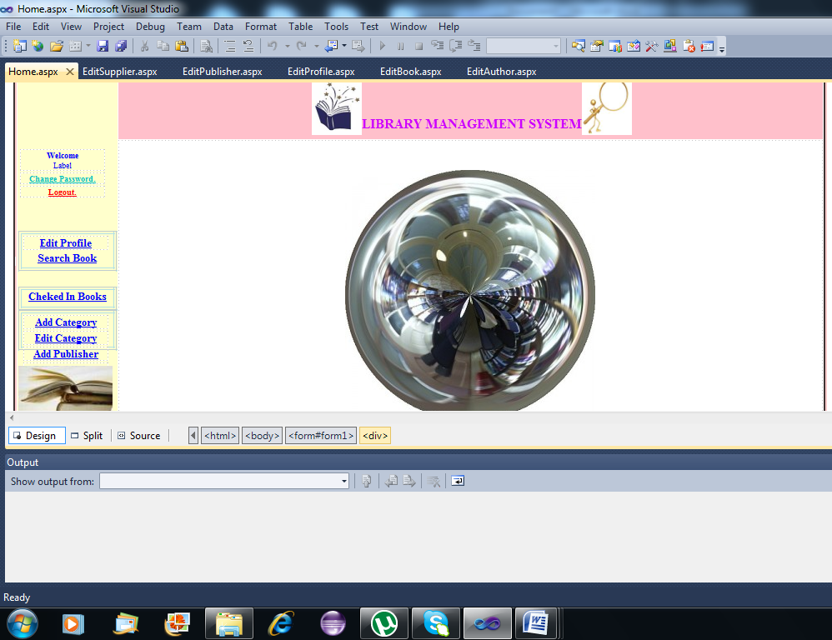

Log in page:
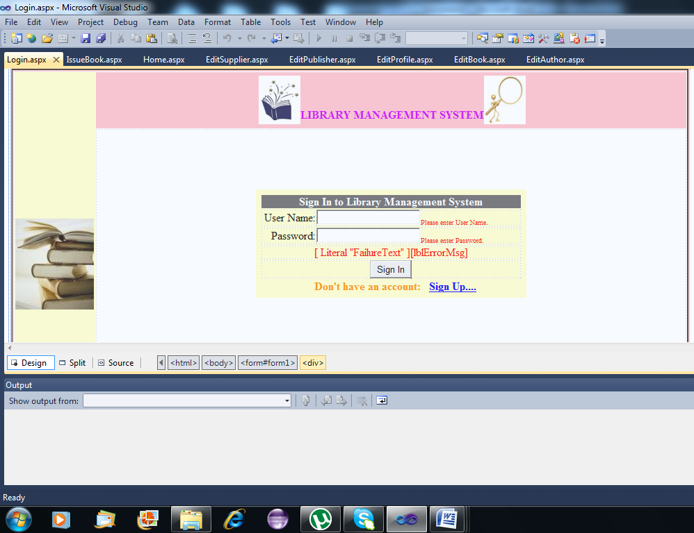

Search book page:

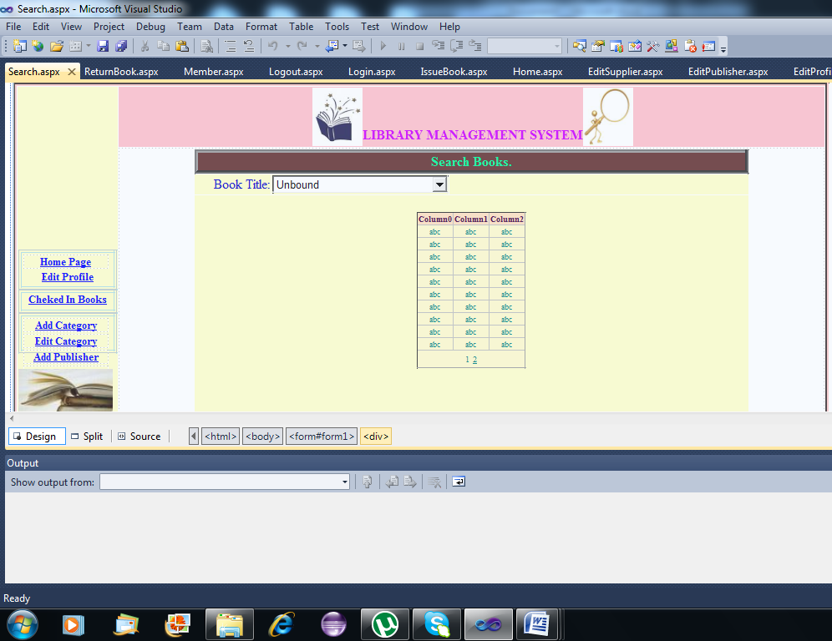

Issue book page:
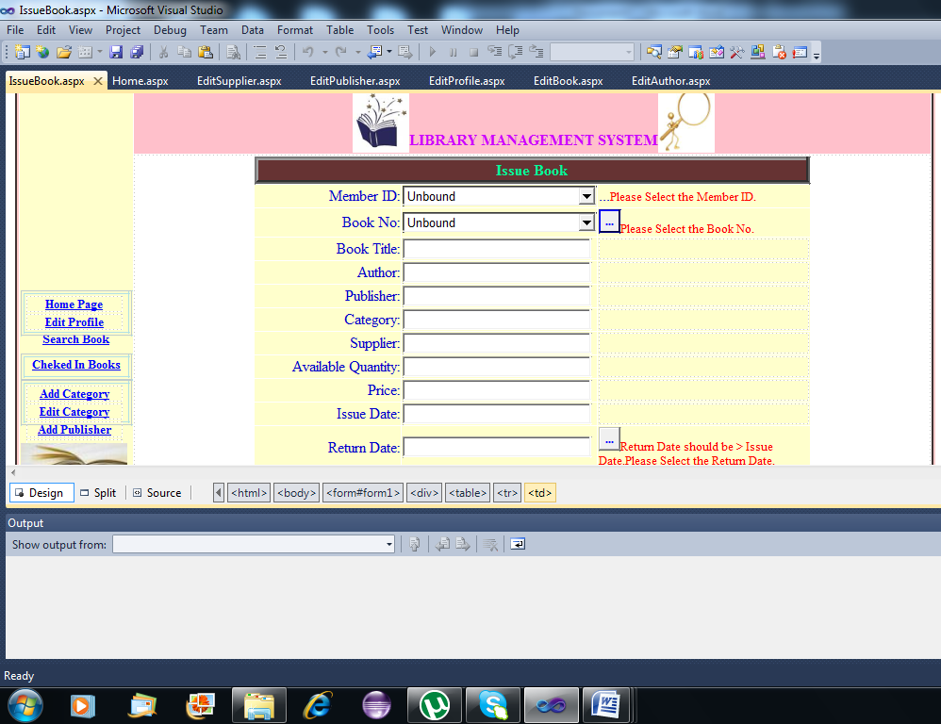

Return book page:

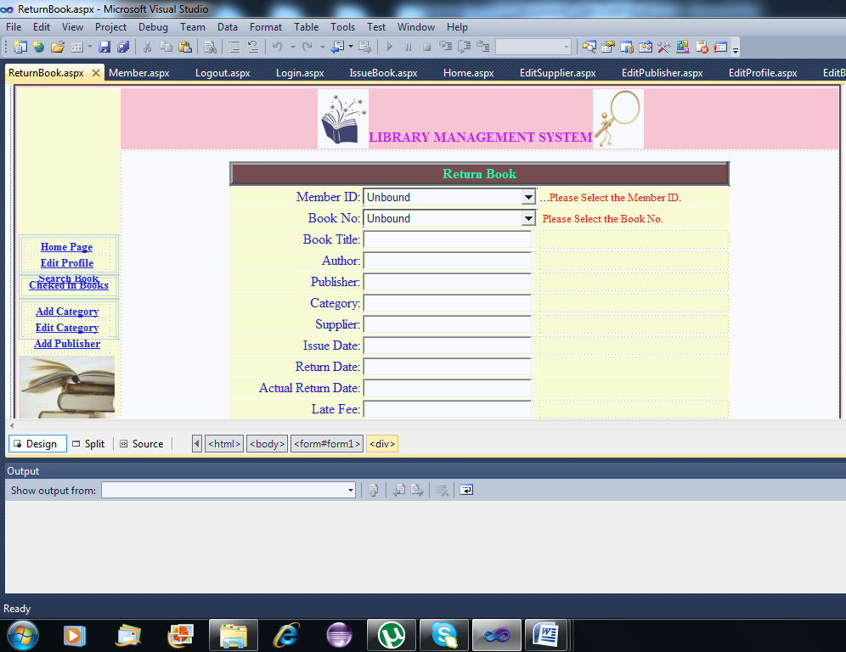

Checked in books
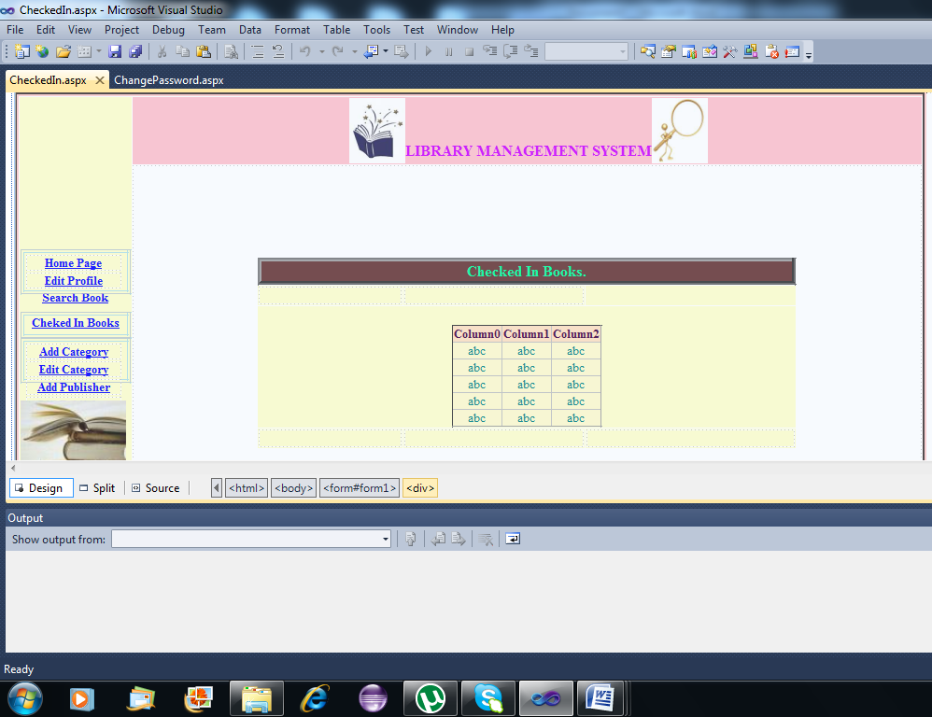

Add new book page:

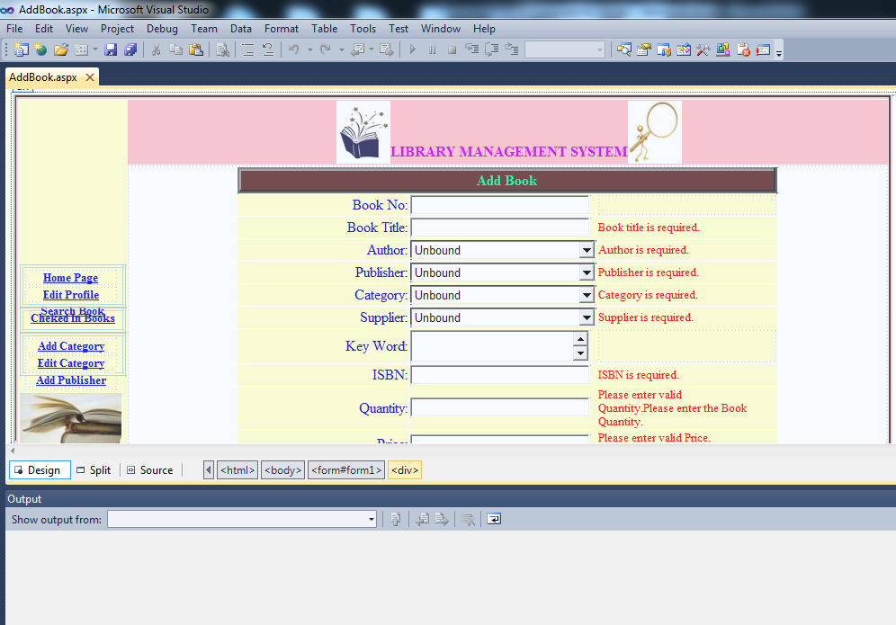

Edit/ Remove page:

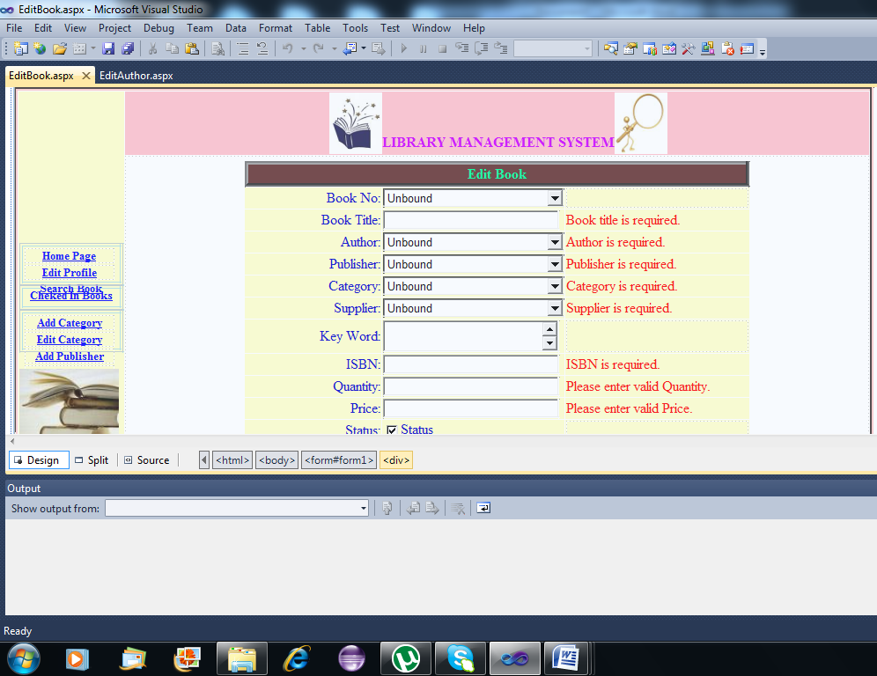

Log out page:

